**GUJARAT TECHNOLOGICAL UNIVERSITY**

Chandkheda, Ahmedabad

Affiliated

**S. S. Agrawal Institute of Engineering**

**& Technology**

An

Internship report on

**“Food Ordering Website”**

Under the course of

**SUMMER INTERNSHIP**

(SUBJECT CODE:4330001) D.E. II, Semester – III

(Diploma Computer Engineering)

Submitted by:

|  |  |  |
| --- | --- | --- |
| SR. | Enrollment No. | Name |
| 1 | 224590307024 | Nadar Nitesh Kumar Palraj |

PROF. Faculty Name

(Faculty Guide)

PROF. Brijesh Bhandari

(Head Of The Department)

Academic year

(2024-2025)

**CERTIFICATE OF AUTHENICITY**

**S. S. AGRAWAL INSTITUTE OF ENGINEERING & TECHNOLOGY, NAVSARI**



This is to certify that the “Internship Report” submitted by _________________________ (Enrollment No. : __________________) is work done by her and submitted during 2023-2024 academic year, in partial fulfillment of the requirements of Diploma Engineering in Computer Engineer department.

Internal Examiner External Examiner

Faculty Guide Head Of Department

### CERTIFICATE OF INTERNSHIP



**ACKNOWLEDGEMENT**

I am happy that I have successfully completed my internship but it would be incomplete without the names of the people who have helped me to achieve this milestone, I would like to extend my heartiest thanks with deep sense of gratitude and respect to all those who provide me imminence help and guidance during my internship.

I would like to express my deep sense of gratitude to **Dr. (Prof.) Dipesh Shukla**, **Principal, SSAIET, Navsari,** for his continuous effort in creating a competitive environment in our college and encouraging throughout this course.

I would like to express my sincere thanks to **Prof. Brijesh Bhandari, Head of the Department, SSAIET, Navsari** for his continues encouragement, motivation throughout the internship program.

A special thanks to my mentor during this internship program **Prof. _______________________________, SSAIET, Navsari,** for overall directions, suggestions and encouragement.

I would also like thank the platform that helped me to do the online internship, (Company Name), for their support , availability, and insightful comments and for steering me to the right direction whenever I needed it .

I am grateful to thank all those who I had the pleasure to learn with for with for making this demanding time joyful yet efficient, and for taking the time to answer any of my questions.

Finally I must express my very profound gratitude to my parents for providing me with unfailing support and continuous encouragement throughout my years of study leading to this very moment and particularly for their sacrifices.

**ABSTRACT**

This project is developed on a comprehensive **Food Ordering Website** for users to enhance their dining experience through a user-centered approach. The website offers an easy-to-use interface for browsing menus, placing personalized orders, and making safe payments. This, as a result, is able to bring simplicity to users in ordering while streamlining operations of food service providers. Key features developed in the website include tracking orders in real time, management of user accounts, and customer support. This system implements the latest technologies in web development to ensure the responsiveness and reliability of the service that could be considered to alleviate some pain points common for online ordering of food. The design of this website concentrates on ease of use, access, and scalability by building grounds for easy enhancement, adapting to emerging market needs.

**LIST OF CONTENT**

|  |  |  |
| --- | --- | --- |
| **Sr. No.** | **Topic** | **Page No.** |
| 1. | Company Profile |  |
| 2. | Project Overview |  |
| 3. | Outcomes |  |
| 4. | Conclusion |  |
| 5. | References |  |

**Company Profile**



Company Name: TechFusion Technologies

Company Address: S-1/2 Dhir Complex Opposite Samarpan Sadhak Nivas, Eru-Abrama Rd, Vejalpore, Navsari, Gujarat 396445

Website URL: https://techfusiontechnologies.com

Company Type: Software Development.

About the Company: Tech-Fusion is a team of entrepreneurs and innovative thinkers who can visualize and give you an online identity with uniqueness and fineness. Tech-Fusion is an affordable web design company and is reputed as one of the fastest-growing IT companies in the state of Gujarat. Tech-Fusion web zone allows you to get everything done in one place all the way! Tech-Fusion aims to be India's best web hosting, web designing and development company.

**Project Overview**

* **App.py**

from flask import Flask,render_template,request,redirect,url_for,flash,session

from flask_mysqldb import MySQL

import os

app = Flask(__name__)

app.secret_key = "food application"

app.config['MYSQL_HOST'] = 'localhost'

app.config['MYSQL_USER'] = 'root'

app.config['MYSQL_PASSWORD'] = ''

app.config['MYSQL_DB'] = 'food'

mysql = MySQL(app)

app.config["UPLOAD_FOLDER"] = 'static/assets/'

@app.route("/")

def index():

cursor = mysql.connection.cursor()

cursor.execute("select * from Product")

data = cursor.fetchall()

cursor.close()

return render_template("index.html",data=list(data))

@app.route("/<cat>")

def category_vise(cat):

cursor = mysql.connection.cursor()

cursor.execute("select * from Product WHERE category = %s",(cat,))

data = cursor.fetchall()

cursor.close()

return render_template("index.html",data=list(data))

@app.route("/cart")

def cart():

if "email" not in session:

flash("Please, login first")

return redirect(url_for("sign_in"))

else:

cursor = mysql.connection.cursor()

cursor.execute("SELECT cart.id,product.photo,product.name,product.price,cart.quantity FROM cart JOIN product ON cart.product_id = product.id WHERE cart.user_id = %s",(session["id"],))

data = cursor.fetchall()

cursor.execute("SELECT SUM(product.price * cart.quantity),(COUNT(product_id) * 50),(SUM(product.price * cart.quantity) + (COUNT(product_id) * 50)) FROM cart JOIN product ON product.id = cart.product_id WHERE user_id = %s",(session["id"],))

cart_det = cursor.fetchone()

cursor.close()

return render_template("cart.html",data=data,cart_det=cart_det)

@app.route("/cart_delete/<int:id>/")

def cart_delete(id):

cursor = mysql.connection.cursor()

cursor.execute("DELETE FROM cart WHERE id = %s",(id,))

mysql.connection.commit()

flash("Removed from cart")

return redirect(url_for("cart"))

@app.route("/food/<int:id>/")

def food_info(id):

if "email" not in session:

flash("Please, login first")

return redirect(url_for("sign_in"))

else:

cursor = mysql.connection.cursor()

cursor.execute("SELECT * FROM product WHERE id = %s",(id,))

data = cursor.fetchone()

return render_template("foodinfo.html",data=data)

@app.route("/add_cart",methods=["GET","POST"])

def add_cart():

data = request.form

cursor = mysql.connection.cursor()

cursor.execute("INSERT INTO cart ( user_id, product_id, quantity) VALUES (%s,%s,%s)",(session["id"],data["pid"],data["quantity"]))

mysql.connection.commit()

flash("Added to cart")

return redirect(url_for("cart"))

@app.route("/cart_edit/<int:id>/")

def cart_edit(id):

cursor = mysql.connection.cursor()

cursor.execute("SELECT cart.id,product.photo,product.name,product.price,cart.quantity,product.description,product.category FROM cart JOIN product ON cart.product_id = product.id WHERE cart.user_id = %s AND cart.id = %s",(session["id"],id))

data = cursor.fetchone()

return render_template("editcart.html",data=data)

@app.route("/edit_cart",methods=["GET","POST"])

def edit_cart():

data = request.form

cursor = mysql.connection.cursor()

cursor.execute("UPDATE cart SET quantity = %s WHERE id = %s",(data["quantity"],data["cid"]))

mysql.connection.commit()

flash("Cart Edited")

return redirect(url_for("cart"))

@app.route("/checkout",methods=["GET","POST"])

def checkout():

if request.method == "GET":

cursor = mysql.connection.cursor()

cursor.execute("SELECT SUM(product.price * cart.quantity),(COUNT(product_id) * 50),(SUM(product.price * cart.quantity) + (COUNT(product_id) * 50)) FROM cart JOIN product ON product.id = cart.product_id WHERE user_id = %s",(session["id"],))

cart_det = cursor.fetchone()

if cart_det[0] == None :

flash("Enable to checkout")

return redirect(url_for("cart"))

else:

return render_template("checkout.html",cart_det=cart_det)

else:

data = request.form

cursor = mysql.connection.cursor()

cursor.execute("SELECT id,product_id,quantity,((SELECT price FROM product WHERE id = product_id) * (quantity)) FROM cart WHERE user_id = %s",(session["id"],))

cartdatas = cursor.fetchall()

for cartdata in cartdatas :

insertquery = "INSERT INTO orders (user_id,product_id,quantity,price,address,city,state,zip_code,country) VALUES (%s,%s,%s,%s,%s,%s,%s,%s,%s)"

cursor.execute(insertquery,(session["id"],cartdata[1],cartdata[2],(cartdata[3] + 50),data["address"],data["city"],data["state"],data["zip"],data["country"]))

cursor.execute("DELETE FROM cart WHERE id = %s ",(cartdata[0],))

mysql.connection.commit()

cursor.close()

return redirect(url_for("orders"))

@app.route("/orders")

def orders():

if "email" not in session:

flash("Please, login first")

return redirect(url_for("sign_in"))

else:

cursor = mysql.connection.cursor()

cursor.execute("SELECT (SELECT photo FROM product WHERE id = product_id),(SELECT name FROM product WHERE id = product_id),price,quantity,status FROM orders WHERE user_id = %s ORDER BY order_date DESC",(session["id"],))

orderdata = cursor.fetchall()

cursor.close()

return render_template("orders.html",orders=orderdata)

@app.route("/sign_in",methods=["GET","POST"])

def sign_in():

if request.method == "GET":

return render_template("signin.html")

else:

data = request.form

cursor = mysql.connection.cursor()

cursor.execute("select email,password,id from users WHERE email = %s",(data["email"],))

record = cursor.fetchone()

cursor.close()

if record :

if data["email"] == record[0] and data["password"] == record[1] :

session["id"] = record[2]

session["email"] = data["email"]

session["password"] = data["password"]

return redirect(url_for("index"))

elif data["email"] == record[0] and data["password"] != record[1]:

flash("Password Wrong")

return redirect(url_for("sign_in"))

else:

flash("Unknown error")

return redirect(url_for("sign_in"))

elif data["email"]=="admin@gmail.com" and data["password"]=="admin@123":

session["admin"] = data["email"]

return redirect(url_for("admin_home"))

else:

flash("Account not found")

return redirect(url_for("sign_in"))

@app.route("/logout")

def logout():

session.pop("email",None)

session.pop("password",None)

return redirect(url_for("sign_in"))

@app.route("/register",methods=["GET","POST"])

def register():

if request.method == "GET":

return render_template("register.html")

else:

data = request.form

cursor = mysql.connection.cursor()

query = "INSERT INTO Users (name, email, phone, password) VALUES (%s,%s,%s,%s)"

cursor.execute(query,(data["name"],data["email"],data["phone"],data["password"]))

mysql.connection.commit()

cursor.close()

flash("Successfully Registered")

return redirect(url_for("sign_in"))

@app.route("/admin_home",methods=["GET","POST"])

def admin_home():

if "admin" in session:

if request.method == "GET":

return render_template("admin_home.html")

else:

data = request.form

photo = request.files["photo"]

photo.save(os.path.join(app.config["UPLOAD_FOLDER"],photo.filename))

cursor = mysql.connection.cursor()

cursor.execute("INSERT INTO Product (name, photo, category, price, description) VALUES (%s,%s,%s,%s,%s);",(data["name"],photo.filename,data["category"],data["price"],data["desc"]))

mysql.connection.commit()

cursor.close()

return redirect(url_for("admin_items"))

else:

flash("Please, sign in as admin")

return redirect(url_for("sign_in"))

@app.route("/admin_items")

def admin_items():

if "admin" in session:

cursor = mysql.connection.cursor()

cursor.execute("select * from Product")

data = cursor.fetchall()

cursor.close()

return render_template("admin_items.html",data=list(data))

else:

flash("Please, sign in as admin")

return redirect(url_for("sign_in"))

@app.route("/delete/<int:id>")

def delete(id):

cursor = mysql.connection.cursor()

cursor.execute("DELETE FROM Product WHERE id = %s",(id,))

mysql.connection.commit()

cursor.close()

return redirect(url_for("admin_items"))

@app.route("/admin_orders")

def admin_orders():

if "admin" in session:

cursor = mysql.connection.cursor()

cursor.execute("SELECT orders.id,product.photo,product.name,orders.quantity,orders.price,orders.address,orders.city,.orders.zip_code,orders.state,orders.country,(SELECT name FROM users WHERE id = user_id),orders.status FROM orders JOIN product WHERE orders.product_id = product.id ORDER BY order_date DESC")

data = cursor.fetchall()

return render_template("admin_orders.html",data=data)

else:

flash("Please, sign in as admin")

return redirect(url_for("sign_in"))

@app.route("/order_update/<int:id>",methods=["GET","POST"])

def order_update(id):

if request.method == "POST":

data = request.form["status"]

cursor = mysql.connection.cursor()

cursor.execute("UPDATE orders SET status = %s WHERE id = %s",(data,id))

mysql.connection.commit()

return redirect(url_for("admin_orders"))

@app.route("/logout_admin")

def logout_admin():

session.pop("admin",None)

return redirect(url_for("sign_in"))

if __name__ == "__main__":

app.run(debug=True,host='0.0.0.0')

* **Admin_home.html**

<!DOCTYPE html>

<html lang="en">

<head>

<meta charset="UTF-8">

<meta name="viewport" content="width=device-width, initial-scale=1.0">

<title>Home | Food Website</title>

<script src="https://cdn.tailwindcss.com/"></script>

<link rel="shortcut icon" href="/static/assets/favicon.png" type="image/x-icon">

<link rel="stylesheet" href="https://cdn.jsdelivr.net/npm/bootstrap-icons@1.11.3/font/bootstrap-icons.min.css">

<link rel="stylesheet" href="{{url_for('static',filename='style.css')}}">

</head>

<body class="w-full h-screen flex flex-col">

<div class="px-[2vw] py-[2vh] w-full flex justify-between items-center border-b-[1px] border-[#747474]">

<div class="left-part">

<img src="/static/assets/logo.png" alt="" class="logo w-[130px]" />

<p>Admin Panel</p>

</div>

<div class="logo flex items-center gap-[2vw]">

<img src="/static/assets/profile_icon.png" alt="">

<a href="/logout_admin"><img src="/static/assets/logout_icon.png" alt=""></a>

</div>

</div>

<main class="w-screen flex flex-1 justify-between overflow-x-hidden">

<aside class="h-[100%] w-[15vw] border-r-[1px] border-[#747474] ps-3 pt-3 flex-col gap-3">

<a href="/admin_home" class="flex gap-2 items-center bg-orange-300 p-2">

<i class="bi bi-plus-circle text-[1.2rem]"></i>

<p>Add items</p>

</a>

<a href="/admin_items" class="flex gap-2 items-center p-2">

<i class="bi bi-list-ul text-[1.2rem]"></i>

<p>List items</p>

</a>

<a href="/admin_orders" class="flex gap-2 items-center p-2">

<i class="bi bi-cart text-[1.2rem]"></i>

<p>Orders</p>

</a>

</aside>

<section class="flex-1 h-full w-full p-[3vw]">

<form action="/admin_home" class="flex flex-col gap-2" enctype="multipart/form-data" method="post">

<p>Upload Image</p>

<div id="uploadIcon" class="w-[150px] h-[100px] bg-slate-100 flex flex-col justify-center items-center">

<i class="bi bi-cloud-upload text-[1.5rem]"></i>

<p>Upload</p>

</div>

<input type="file" name="photo" id="fileField" required class="hidden">

<p>Product Name</p>

<input type="text" placeholder="Type here" name="name" class="py-1 ps-2 border-[1px] border-[#747474] w-[30vw]" required>

<p>Product Description</p>

<textarea name="desc" class="p-2 h-[100px] resize-none border-[1px] border-[#747474] w-[30vw]" placeholder="Write content here" required></textarea>

<div class="wrapper flex gap-3">

<div class="lf flex-col flex gap-2">

<p>Product Category</p>

<select name="category" class="p-2 border-[1px] border-[#747474] w-[12vw]" required>

<option value="Salad">Salad</option>

<option value="Rolls">Rolls</option>

<option value="Deserts">Deserts</option>

<option value="Sandwich">Sandwich</option>

<option value="Cake">Cake</option>

<option value="Pure Veg">Pure Veg</option>

<option value="Pasta">Pasta</option>

<option value="Noodles">Noodles</option>

</select>

</div>

<div class="lf flex-col flex gap-2">

<p>Product Price</p>

<input name="price" class="p-2 border-[1px] border-[#747474] w-[12vw]" required placeholder="₹25">

</div>

</div>

<button type="submit" class="flex items-center gap-1 text-white px-3 py-2 mt-2 bg-black w-max">

<i class="bi bi-plus"></i>

<p>ADD</p>

</button>

</form>

</section>

</main>

<script>

let uploadBtn = document.getElementById("uploadIcon");

uploadBtn.addEventListener('click',()=>{

document.getElementById("fileField").click()

})

</script>

</body>

</html>

* **Admin_items.html**

<!DOCTYPE html>

<html lang="en">

<head>

<meta charset="UTF-8">

<meta name="viewport" content="widp=device-widp, initial-scale=1.0">

<title>Home | Food Website</title>

<script src="https://cdn.tailwindcss.com/"></script>

<link rel="shortcut icon" href="/static/assets/favicon.png" type="image/x-icon">

<link rel="stylesheet" href="https://cdn.jsdelivr.net/npm/bootstrap-icons@1.11.3/font/bootstrap-icons.min.css">

<link rel="stylesheet" href="{{url_for('static',filename='style.css')}}">

</head>

<body class="w-full h-screen flex flex-col">

<div class="px-[2vw] py-[2vh] w-full flex justify-between items-center border-b-[1px] border-[#747474]">

<div class="left-part">

<img src="/static/assets/logo.png" alt="" class="logo w-[130px]" />

<p>Admin Panel</p>

</div>

<div class="logo flex items-center gap-[2vw]">

<img src="/static/assets/profile_icon.png" alt="">

<a href="/logout_admin"><img src="/static/assets/logout_icon.png" alt=""></a>

</div>

</div>

<main class="w-screen flex flex-1 justify-between overflow-x-hidden">

<aside class="h-[100%] w-[15vw] border-r-[1px] border-[#747474] ps-3 pt-3 flex-col gap-3">

<a href="/admin_home" class="flex gap-2 items-center p-2">

<i class="bi bi-plus-circle text-[1.2rem]"></i>

<p>Add items</p>

</a>

<a href="/admin_items" class="flex gap-2 items-center p-2 bg-orange-300">

<i class="bi bi-list-ul text-[1.2rem]"></i>

<p>List items</p>

</a>

<a href="/admin_orders" class="flex gap-2 items-center p-2">

<i class="bi bi-cart text-[1.2rem]"></i>

<p>Orders</p>

</a>

</aside>

<section class="flex-1 h-full w-full p-[3vw]">

<h2 class="mb-3 text-xl font-semibold">All Food List</h2>

<div class="w-full border-[1px] border-[#747474]">

<div class="text-center flex justify-around border-b-[1px] p-2 border-[#747474]">

<p>Image</p>

<p>Name</p>

<p>Category</p>

<p>Price</p>

<p>Action</p>

</div>

{% for id,name,url,cat,price,desc in data %}

<div class="p-3 flex justify-around border-b-[1px] p-2 border-[#747474] items-center">

<img src="/static/assets/{{url}}" class="w-[10vh] h-[10vh] object-cover object-center">

<p>{{name}}</p>

<p>{{cat}}</p>

<p>₹{{price}}</p>

<p>

<a href="/delete/{{id}}" class="p-2 bg-red-300 rounded-md mr-2"><i class="bi bi-x-lg"></i></a>

<a href="" class="p-2 bg-yellow-300 rounded-md"><i class="bi bi-pencil-square"></i></a>

</p>

</div>

{% endfor %}

</div>

</section>

</main>

</body>

</html>

* **Admin_orders.html**

<!DOCTYPE html>

<html lang="en">

<head>

<meta charset="UTF-8">

<meta name="viewport" content="widp=device-widp, initial-scale=1.0">

<title>Home | Food Website</title>

<script src="https://cdn.tailwindcss.com/"></script>

<link rel="shortcut icon" href="/static/assets/favicon.png" type="image/x-icon">

<link rel="stylesheet" href="https://cdn.jsdelivr.net/npm/bootstrap-icons@1.11.3/font/bootstrap-icons.min.css">

<link rel="stylesheet" href="{{url_for('static',filename='style.css')}}">

</head>

<body class="w-full h-screen flex flex-col">

<div class="px-[2vw] py-[2vh] w-full flex justify-between items-center border-b-[1px] border-[#747474]">

<div class="left-part">

<img src="/static/assets/logo.png" alt="" class="logo w-[130px]" />

<p>Admin Panel</p>

</div>

<div class="logo flex items-center gap-[2vw]">

<img src="/static/assets/profile_icon.png" alt="">

<a href="/logout_admin"><img src="/static/assets/logout_icon.png" alt=""></a>

</div>

</div>

<main class="w-screen flex flex-1 justify-between overflow-x-hidden">

<aside class="h-[100%] w-[15vw] border-r-[1px] border-[#747474] ps-3 pt-3 flex-col gap-3">

<a href="/admin_home" class="flex gap-2 items-center p-2">

<i class="bi bi-plus-circle text-[1.2rem]"></i>

<p>Add items</p>

</a>

<a href="/admin_items" class="flex gap-2 items-center p-2 bg-orange-300">

<i class="bi bi-list-ul text-[1.2rem]"></i>

<p>List items</p>

</a>

<a href="/admin_orders" class="flex gap-2 items-center p-2">

<i class="bi bi-cart text-[1.2rem]"></i>

<p>Orders</p>

</a>

</aside>

<section class="flex-1 h-full w-full p-[3vw]">

<h2 class="mb-3 text-xl font-semibold">All Food List</h2>

<div class="w-full border-[1px] border-[#747474]">

<div class="text-center flex justify-around border-b-[1px] p-2 border-[#747474]">

<p>Image</p>

<p>Name</p>

<p>Category</p>

<p>Price</p>

<p>Action</p>

</div>

{% for id,name,url,cat,price,desc in data %}

<div class="p-3 flex justify-around border-b-[1px] p-2 border-[#747474] items-center">

<img src="/static/assets/{{url}}" class="w-[10vh] h-[10vh] object-cover object-center">

<p>{{name}}</p>

<p>{{cat}}</p>

<p>₹{{price}}</p>

<p>

<a href="/delete/{{id}}" class="p-2 bg-red-300 rounded-md mr-2"><i class="bi bi-x-lg"></i></a>

<a href="" class="p-2 bg-yellow-300 rounded-md"><i class="bi bi-pencil-square"></i></a>

</p>

</div>

{% endfor %}

</div>

</section>

</main>

</body>

</html>

* **cart.html**

<!DOCTYPE html>

<html lang="en">

<head>

<meta charset="UTF-8">

<meta name="viewport" content="width=device-width, initial-scale=1.0">

<title>Cart | Food Website</title>

<script src="https://cdn.tailwindcss.com/"></script>

<link rel="shortcut icon" href="/static/assets/favicon.png" type="image/x-icon">

<link rel="stylesheet" href="{{url_for('static',filename='style.css')}}">

<link rel="stylesheet" href="https://cdn.jsdelivr.net/npm/bootstrap-icons@1.11.3/font/bootstrap-icons.min.css">

</head>

<style>

table th,

td {

padding: 10px 10px;

border-bottom: 2px solid #ddd;

}

</style>

<body class="overflow-x-hidden relative">

{% with messages = get_flashed_messages() %}

{% if messages %}

{% for message in messages %}

<div class="message border-[1px] shadow-2x shadow-slate-500 p-3 absolute right-[3vw] top-[5vw] bg-white border-b-[3px] border-[tomato]">

<p>{{ message }} &nbsp;<i class="bi bi-x-lg"></i></p>

</div>

{% endfor %}

{% endif %}

{% endwith %}

<div class="app min-h-screen flex justify-between flex-col z-50">

<header class="py-[20px] w-full flex justify-between items-center">

<a href="/">

<img src="/static/assets/logo.png" alt="" class="logo w-[150px]" />

</a>

<ul class="navbar-menu flex gap-[20px] text-[#49557e] text-[18px]">

<li class="active">home</li>

<li>menu</li>

<li>mobile-app</li>

<li>contact us</li>

</ul>

<div class="navbar-right flex items-center gap-[40px]">

<img src="/static/assets/search_icon.png" alt="" />

<a href="/cart" class="navbar-search-icon relative">

<img src="/static/assets/basket_icon.png" alt="" />

<div

class="dot absolute min-w-[10px] min-h-[10px] bg-[tomato] rounded-[5px] -top-[8px] -right-[8px]">

</div>

</a>

{% if "email" not in session %}

<a href="/sign_in"

class="bg-transparent text-[16px] duration-300 text-[#49557e] border-[1px] hover:bg-[#fff4f2] border-[tomato] py-[10px] px-[30px] rounded-[50px] cursor-pointer">sign

in</a>

{% else %}

<a href="/orders"><i class="bi bi-truck text-[2rem] text-[#49557e]"></i></a>

<a href="/logout"><img src="/static/assets/logout_icon.png" alt=""></a>

{% endif %}

</div>

</header>

<div class="cart-info py-[2vh]">

<h1 class="text-2xl font-bold text-center border-b-[1px] border-[#ddd] pb-4">Your Cart</h1>

<table class="text-center w-full shadow-md">

<thead>

<tr>

<th>Item</th>

<th>Title</th>

<th>Price</th>

<th>Quantity</th>

<th>Total</th>

<th>Action</th>

</tr>

</thead>

<tbody>

{% if data | length > 0 %}

{% for id,photo,name,price,quantity in data %}

<tr>

<td>

<img src="/static/assets/{{photo}}"

class="mx-auto w-[10vh] h-[10vh] object-cover object-center">

</td>

<td>{{name}}</td>

<td>{{price}} ₹</td>

<td>{{quantity}}</td>

<td>{{price * quantity}} ₹</td>

<td>

<a href="/cart_delete/{{id}}/" class="p-2 bg-red-300 rounded-md mr-2"><i class="bi bi-x-lg"></i></a>

<a href="/cart_edit/{{id}}/" class="p-2 bg-yellow-300 rounded-md"><i

class="bi bi-pencil-square"></i></a>

</td>

</tr>

{% endfor%}

{% else %}

<tr>

<td colspan="6">

Cart is empty.

</td>

</tr>

{% endif%}

</tbody>

</table>

</div>

<div class="cart-pay flex justify-between py-[3vh]">

<div class="total w-[30vw] flex flex-col gap-1">

<h1 class="text-xl font-bold py-3">Cart Total</h1>

{% if cart_det[0] != None %}

<div class="w-full py-2 flex items-center justify-between border-b-[1px] border-[#ddd]">

<span>SubTotal</span>

<span>{{cart_det[0]}} ₹</span>

</div>

<div class="w-full py-2 flex items-center justify-between border-b-[1px] border-[#ddd]">

<span>Delivery Fee</span>

<span>{{cart_det[1]}} ₹</span>

</div>

<div class="w-full py-2 flex items-center justify-between border-b-[1px] border-[#ddd]">

<span class="font-semibold">Total</span>

<span class="font-semibold">{{cart_det[2]}} ₹</span>

</div>

<a href="/checkout" class="bg-[tomato] rounded-[5px] w-max my-2 px-6 py-2 text-white">Proceed to checkout</a>

{% else %}

<div class="w-full py-2 flex items-center justify-between border-b-[1px] border-[#ddd]">

<span>SubTotal</span>

<span>0 ₹</span>

</div>

<div class="w-full py-2 flex items-center justify-between border-b-[1px] border-[#ddd]">

<span>Delivery Fee</span>

<span>0 ₹</span>

</div>

<div class="w-full py-2 flex items-center justify-between border-b-[1px] border-[#ddd]">

<span class="font-semibold">Total</span>

<span class="font-semibold">0 ₹</span>

</div>

{% endif %}

</div>

<div class="promo w-[30vw]">

<p class="mb-2">If you have a promo code, Enter it here. </p>

<div class="inp w-full flex items-center justify-between">

<input type="text" placeholder="promo code"

class="flex-1 py-2 bg-slate-100 placeholder:text-slate-500 px-2 shadow-md">

<button class="bg-black px-6 py-2 text-white rounded-[5px]">Submit</button>

</div>

</div>

</div>

<footer class="w-full h-max bg-slate-600 flex justify-center items-center text-white flex-col">

<div class="footer-container flex justify-between gap-[1vw] p-7">

<div class="footer-left flex-1 flex flex-col gap-3">

<img src="/static/assets/logo.png" alt="" class="w-[150px]">

<p class="text-justify w-[90%]">Lorem ipsum dolor sit amet consectetur, adipisicing elit. Similique iste

illum atque fugiat inventore unde quod nemo. Nostrum, accusamus cupiditate?</p>

<div class="social-icons flex gap-3">

<img src="/static/assets/facebook_icon.png" alt="" class="w-[30px] h-[30px]">

<img src="/static/assets/twitter_icon.png" alt="" class="w-[30px] h-[30px]">

<img src="/static/assets/linkedin_icon.png" alt="" class="w-[30px] h-[30px]">

</div>

</div>

<div class="footer-center w-max pe-[5vw]">

<h2 class="text-lg mb-2">COMPANY</h2>

<ul>

<li>Home</li>

<li>About us</li>

<li>Delivery</li>

<li>Privacy policy</li>

</ul>

</div>

<div class="footer-right w-max pe-[5vw]">

<h2 class="text-lg mb-2">GET IN TOUCH</h2>

<ul>

<li>+91 1234567890</li>

<li>info@tomato.com</li>

</ul>

</div>

</div>

<div class="line w-full h-[2px] bg-[#fff]"></div>

<p class="capitalize my-3">Copyright@2024 | All rights reserved for educational Purpose</p>

</footer>

</div>

<script src="https://cdn.jsdelivr.net/npm/gsap@3.12.5/dist/gsap.min.js"></script>

<script>

let tl = gsap.timeline()

tl.from(".left",{

width:"0",

ease: "sine",

duration: 1,

transformOrigin: "right"

})

.from(".message",{

right: '-600px',

duration: 1,

ease: "bounce"

})

.to(".message",{

right: "-400px",

duration:1,

ease:"sine",

delay:1

})

</script>

</body>

</html>

* **checkout.html**

<!DOCTYPE html>

<html lang="en">

<head>

<meta charset="UTF-8">

<meta name="viewport" content="width=device-width, initial-scale=1.0">

<title>Checkout | Food Website</title>

<script src="https://cdn.tailwindcss.com/"></script>

<link rel="stylesheet" href="{{url_for('static',filename='style.css')}}">

<link rel="shortcut icon" href="/static/assets/favicon.png" type="image/x-icon">

<link rel="stylesheet" href="https://cdn.jsdelivr.net/npm/bootstrap-icons@1.11.3/font/bootstrap-icons.min.css">

</head>

<style>

table th,

td {

padding: 10px 10px;

border-bottom: 2px solid #ddd;

}

</style>

<body class="overflow-x-hidden relative">

<div class="app min-h-screen flex justify-between flex-col z-50">

<header class="py-[20px] w-full flex justify-between items-center">

<a href="/">

<img src="/static/assets/logo.png" alt="" class="logo w-[150px]" />

</a>

<ul class="navbar-menu flex gap-[20px] text-[#49557e] text-[18px]">

<li class="active">home</li>

<li>menu</li>

<li>mobile-app</li>

<li>contact us</li>

</ul>

<div class="navbar-right flex items-center gap-[40px]">

<img src="/static/assets/search_icon.png" alt="" />

<a href="/cart" class="navbar-search-icon relative">

<img src="/static/assets/basket_icon.png" alt="" />

<div

class="dot absolute min-w-[10px] min-h-[10px] bg-[tomato] rounded-[5px] -top-[8px] -right-[8px]">

</div>

</a>

{% if "email" not in session %}

<a href="/sign_in"

class="bg-transparent text-[16px] duration-300 text-[#49557e] border-[1px] hover:bg-[#fff4f2] border-[tomato] py-[10px] px-[30px] rounded-[50px] cursor-pointer">sign

in</a>

{% else %}

<a href="/orders"><i class="bi bi-truck text-[2rem] text-[#49557e]"></i></a>

<a href="/logout"><img src="/static/assets/logout_icon.png" alt=""></a>

{% endif %}

</div>

</header>

<form action="/checkout" method="post" class="delivery-info w-full flex justify-between pb-4">

<div class="w-[40vw] flex flex-col gap-2">

<h1 class="text-xl font-bold py-3">Delivery Information</h1>

<textarea required name="address" placeholder="Address" class="w-full h-[150px] resize-none px-1 border-[#000] border-[1px] rounded-md"></textarea>

<div class="inp w-full flex justify-between gap-2">

<input required type="text" class="py-2 w-1/2 px-1 border-[#000] border-[1px] rounded-md" placeholder="City" name="city">

<input required type="text" class="py-2 w-1/2 px-1 border-[#000] border-[1px] rounded-md" placeholder="State" name="state">

</div>

<div class="inp w-full flex justify-between gap-2">

<input required type="number" class="py-2 w-1/2 px-1 border-[#000] border-[1px] rounded-md" placeholder="Zip code" name="zip">

<input required type="text" class="py-2 w-1/2 px-1 border-[#000] border-[1px] rounded-md" placeholder="Country" name="country">

</div>

</div>

<div class="total w-[30vw] flex flex-col gap-1">

<h1 class="text-xl font-bold py-3">Cart Total</h1>

<div class="w-full py-2 flex items-center justify-between border-b-[1px] border-[#ddd]">

<span>SubTotal</span>

<span>{{cart_det[0]}} ₹</span>

</div>

<div class="w-full py-2 flex items-center justify-between border-b-[1px] border-[#ddd]">

<span>Delivery Fee</span>

<span>{{cart_det[1]}} ₹</span>

</div>

<div class="w-full py-2 flex items-center justify-between border-b-[1px] border-[#ddd]">

<span>Payment Method</span>

<span>Cash on Delivery</span>

</div>

<div class="w-full py-2 flex items-center justify-between border-b-[1px] border-[#ddd]">

<span class="font-semibold">Total</span>

<span class="font-semibold">{{cart_det[2]}} ₹</span>

</div>

<input type="number" name="price" value="{{cart_det[2]}}" hidden>

<button type="submit" class="bg-[tomato] rounded-[5px] w-max my-2 px-6 py-2 text-white">Proceed to payment</button>

</div>

</form>

<footer class="w-full h-max bg-slate-600 flex justify-center items-center text-white flex-col">

<div class="footer-container flex justify-between gap-[1vw] p-7">

<div class="footer-left flex-1 flex flex-col gap-3">

<img src="/static/assets/logo.png" alt="" class="w-[150px]">

<p class="text-justify w-[90%]">Lorem ipsum dolor sit amet consectetur, adipisicing elit. Similique iste

illum atque fugiat inventore unde quod nemo. Nostrum, accusamus cupiditate?</p>

<div class="social-icons flex gap-3">

<img src="/static/assets/facebook_icon.png" alt="" class="w-[30px] h-[30px]">

<img src="/static/assets/twitter_icon.png" alt="" class="w-[30px] h-[30px]">

<img src="/static/assets/linkedin_icon.png" alt="" class="w-[30px] h-[30px]">

</div>

</div>

<div class="footer-center w-max pe-[5vw]">

<h2 class="text-lg mb-2">COMPANY</h2>

<ul>

<li>Home</li>

<li>About us</li>

<li>Delivery</li>

<li>Privacy policy</li>

</ul>

</div>

<div class="footer-right w-max pe-[5vw]">

<h2 class="text-lg mb-2">GET IN TOUCH</h2>

<ul>

<li>+91 1234567890</li>

<li>info@tomato.com</li>

</ul>

</div>

</div>

<div class="line w-full h-[2px] bg-[#fff]"></div>

<p class="capitalize my-3">Copyright@2024 | All rights reserved for educational Purpose</p>

</footer>

</div>

</body>

</html>

* **editcart.html**

<!DOCTYPE html>

<html lang="en">

<head>

<meta charset="UTF-8">

<meta name="viewport" content="width=device-width, initial-scale=1.0">

<title>Edit Cart | Food Website</title>

<script src="https://cdn.tailwindcss.com/"></script>

<link rel="shortcut icon" href="/static/assets/favicon.png" type="image/x-icon">

<link rel="stylesheet" href="{{url_for('static',filename='style.css')}}">

<link rel="stylesheet" href="https://cdn.jsdelivr.net/npm/bootstrap-icons@1.11.3/font/bootstrap-icons.min.css">

</head>

<body>

<div class="app min-h-screen flex justify-between flex-col z-50">

<header class="py-[20px] w-full flex justify-between items-center">

<a href="/">

<img src="/static/assets/logo.png" alt="" class="logo w-[150px]" />

</a>

<ul class="navbar-menu flex gap-[20px] text-[#49557e] text-[18px]">

<li class="active">home</li>

<li>menu</li>

<li>mobile-app</li>

<li>contact us</li>

</ul>

<div class="navbar-right flex items-center gap-[40px]">

<img src="/static/assets/search_icon.png" alt="" />

<div class="navbar-search-icon relative">

<img src="/static/assets/basket_icon.png" alt="" />

<div class="dot absolute min-w-[10px] min-h-[10px] bg-[tomato] rounded-[5px] -top-[8px] -right-[8px]"></div>

</div>

{% if "email" not in session %}

<a href="/sign_in" class="bg-transparent text-[16px] duration-300 text-[#49557e] border-[1px] hover:bg-[#fff4f2] border-[tomato] py-[10px] px-[30px] rounded-[50px] cursor-pointer">sign in</a>

{% else %}

<a href="/logout"><img src="/static/assets/logout_icon.png" alt=""></a>

{% endif %}

</div>

</header>

<div class="food_info my-3 flex justify-between">

<div class="image-div w-[30vw] h-[30vw]">

<img src="/static/assets/{{data[1]}}" alt="" class="w-full h-full object-center object-cover rounded-md shadow-md">

</div>

<div class="info-div w-[40vw] flex gap-3 flex-col">

<h1 class="text-2xl text-[tomato] font-bold">{{data[2]}}</h1>

<p class="text-slate-500 text-lg">{{data[5]}}</p>

<p class="text-md">Category : {{data[6]}}</p>

<p class="text-md">Price : {{data[3]}}₹</p>

<form action="/edit_cart" method="post">

<div class="inp flex items-center gap-3">

<p>Quantity</p>

<input required type="number" min="1" name="quantity" value="{{data[4]}}" class="bg-slate-100 py-1 px-1 w-[60px] border-b-[1px] outline-0 border-[#000]">

</div>

<input type="text" name="cid" value="{{data[0]}}" hidden>

<button type="submit" class="bg-[tomato] text-white py-2 px-4 rounded-[5px] mt-4">Edit Cart</button>

</form>

</div>

</div>

<footer class="w-full h-max bg-slate-600 flex justify-center items-center text-white flex-col">

<div class="footer-container flex justify-between gap-[1vw] p-7">

<div class="footer-left flex-1 flex flex-col gap-3">

<img src="/static/assets/logo.png" alt="" class="w-[150px]">

<p class="text-justify w-[90%]">Lorem ipsum dolor sit amet consectetur, adipisicing elit. Similique iste illum atque fugiat inventore unde quod nemo. Nostrum, accusamus cupiditate?</p>

<div class="social-icons flex gap-3">

<img src="/static/assets/facebook_icon.png" alt="" class="w-[30px] h-[30px]">

<img src="/static/assets/twitter_icon.png" alt="" class="w-[30px] h-[30px]">

<img src="/static/assets/linkedin_icon.png" alt="" class="w-[30px] h-[30px]">

</div>

</div>

<div class="footer-center w-max pe-[5vw]">

<h2 class="text-lg mb-2">COMPANY</h2>

<ul>

<li>Home</li>

<li>About us</li>

<li>Delivery</li>

<li>Privacy policy</li>

</ul>

</div>

<div class="footer-right w-max pe-[5vw]">

<h2 class="text-lg mb-2">GET IN TOUCH</h2>

<ul>

<li>+91 1234567890</li>

<li>info@tomato.com</li>

</ul>

</div>

</div>

<div class="line w-full h-[2px] bg-[#fff]"></div>

<p class="capitalize my-3">Copyright@2024 | All rights reserved for educational Purpose</p>

</footer>

</div>

</body>

</html>

* **foodinfo.html**

<!DOCTYPE html>

<html lang="en">

<head>

<meta charset="UTF-8">

<meta name="viewport" content="width=device-width, initial-scale=1.0">

<title>Food info | Food Website</title>

<script src="https://cdn.tailwindcss.com/"></script>

<link rel="shortcut icon" href="/static/assets/favicon.png" type="image/x-icon">

<link rel="stylesheet" href="{{url_for('static',filename='style.css')}}">

<link rel="stylesheet" href="https://cdn.jsdelivr.net/npm/bootstrap-icons@1.11.3/font/bootstrap-icons.min.css">

</head>

<body>

<div class="app min-h-screen flex justify-between flex-col z-50">

<header class="py-[20px] w-full flex justify-between items-center">

<a href="/">

<img src="/static/assets/logo.png" alt="" class="logo w-[150px]" />

</a>

<ul class="navbar-menu flex gap-[20px] text-[#49557e] text-[18px]">

<li class="active">home</li>

<li>menu</li>

<li>mobile-app</li>

<li>contact us</li>

</ul>

<div class="navbar-right flex items-center gap-[40px]">

<img src="/static/assets/search_icon.png" alt="" />

<div class="navbar-search-icon relative">

<img src="/static/assets/basket_icon.png" alt="" />

<div class="dot absolute min-w-[10px] min-h-[10px] bg-[tomato] rounded-[5px] -top-[8px] -right-[8px]"></div>

</div>

{% if "email" not in session %}

<a href="/sign_in" class="bg-transparent text-[16px] duration-300 text-[#49557e] border-[1px] hover:bg-[#fff4f2] border-[tomato] py-[10px] px-[30px] rounded-[50px] cursor-pointer">sign in</a>

{% else %}

<a href="/logout"><img src="/static/assets/logout_icon.png" alt=""></a>

{% endif %}

</div>

</header>

<div class="food_info my-3 flex justify-between">

<div class="image-div w-[30vw] h-[30vw]">

<img src="/static/assets/{{data[2]}}" alt="" class="w-full h-full object-center object-cover rounded-md shadow-md">

</div>

<!-- id,name,url,cat,price,desc -->

<div class="info-div w-[40vw] flex gap-3 flex-col">

<h1 class="text-2xl text-[tomato] font-bold">{{data[1]}}</h1>

<p class="text-slate-500 text-lg">{{data[5]}}</p>

<p class="text-md">Category : {{data[3]}}</p>

<p class="text-md">Price : {{data[4]}}₹</p>

<form action="/add_cart" method="post">

<div class="inp flex items-center gap-3">

<p>Quantity</p>

<input required type="number" min="1" name="quantity" class="bg-slate-100 py-1 px-1 w-[60px] border-b-[1px] outline-0 border-[#000]">

</div>

<input type="text" name="pid" value="{{data[0]}}" hidden>

<button type="submit" class="bg-[tomato] text-white py-2 px-4 rounded-[5px] mt-4">Add To Cart</button>

</form>

</div>

</div>

<footer class="w-full h-max bg-slate-600 flex justify-center items-center text-white flex-col">

<div class="footer-container flex justify-between gap-[1vw] p-7">

<div class="footer-left flex-1 flex flex-col gap-3">

<img src="/static/assets/logo.png" alt="" class="w-[150px]">

<p class="text-justify w-[90%]">Lorem ipsum dolor sit amet consectetur, adipisicing elit. Similique iste illum atque fugiat inventore unde quod nemo. Nostrum, accusamus cupiditate?</p>

<div class="social-icons flex gap-3">

<img src="/static/assets/facebook_icon.png" alt="" class="w-[30px] h-[30px]">

<img src="/static/assets/twitter_icon.png" alt="" class="w-[30px] h-[30px]">

<img src="/static/assets/linkedin_icon.png" alt="" class="w-[30px] h-[30px]">

</div>

</div>

<div class="footer-center w-max pe-[5vw]">

<h2 class="text-lg mb-2">COMPANY</h2>

<ul>

<li>Home</li>

<li>About us</li>

<li>Delivery</li>

<li>Privacy policy</li>

</ul>

</div>

<div class="footer-right w-max pe-[5vw]">

<h2 class="text-lg mb-2">GET IN TOUCH</h2>

<ul>

<li>+91 1234567890</li>

<li>info@tomato.com</li>

</ul>

</div>

</div>

<div class="line w-full h-[2px] bg-[#fff]"></div>

<p class="capitalize my-3">Copyright@2024 | All rights reserved for educational Purpose</p>

</footer>

</div>

</body>

</html>

* **index.html**

<!DOCTYPE html>

<html lang="en">

<head>

<meta charset="UTF-8">

<meta name="viewport" content="width=device-width, initial-scale=1.0">

<title>Home | Food Website</title>

<script src="https://cdn.tailwindcss.com/"></script>

<link rel="shortcut icon" href="/static/assets/favicon.png" type="image/x-icon">

<link rel="stylesheet" href="{{url_for('static',filename='style.css')}}">

<link rel="stylesheet" href="https://cdnjs.cloudflare.com/ajax/libs/font-awesome/6.2.1/css/all.min.css" />

</head>

<body class="w-full relative">

<section class="fixed bg-black/50 w-screen hidden h-[100vh] z-99"></section>

<div class="app min-h-screen z-50">

<header class="py-[20px] w-full flex justify-between items-center">

<img src="/static/assets/logo.png" alt="" class="logo w-[150px]" />

<ul class="navbar-menu flex gap-[20px] text-[#49557e] text-[18px]">

<li class="active">home</li>

<li>menu</li>

<li>mobile-app</li>

<li>contact us</li>

</ul>

<div class="navbar-right flex items-center gap-[40px]">

<img src="/static/assets/search_icon.png" alt="" />

<a href="/cart" class="navbar-search-icon relative">

<img src="/static/assets/basket_icon.png" alt="" />

<div class="dot absolute min-w-[10px] min-h-[10px] bg-[tomato] rounded-[5px] -top-[8px] -right-[8px]"></div>

</a>

{% if "email" not in session %}

<a href="/sign_in" class="bg-transparent text-[16px] duration-300 text-[#49557e] border-[1px] hover:bg-[#fff4f2] border-[tomato] py-[10px] px-[30px] rounded-[50px] cursor-pointer">sign in</a>

{% else %}

<a href="/logout"><img src="/static/assets/logout_icon.png" alt=""></a>

{% endif %}

</div>

</header>

<div style="background-image: url(/static/assets/header_img.png);" class="header h-[34vw] my-[30px] mx-auto bg-no-repeat bg-contain relative" style="background-image: url(assets/header_img.png);">

<div class="header-contents animate-fadeIn absolute flex flex-col items-start gap-[1.5vw] max-w-[50%] bottom-[10%] left-[6vw]">

<h2 class="text-[#fff] text-[max(4.5vw)] font-md">Order your favourite food here</h2>

<p class="text-white text-[1vw]">Choose from a diverse menu featuring a delectable array od dishes crafted with the finest ingredients and culinary expertise. Our mission is to satisfy your cravings and elevate your dining experience, one delicious meal at a time.</p>

<button class="text-[#747474] font-md px-[2.3vw] py-[1vw] bg-white rounded-[50px] text-[1vw]">View menu</button>

</div>

</div>

<div class="info flex flex-col gap-[10px] mb-3">

<h2 class="font-md text-[2.3vw]">Explore our menu</h2>

<p class="text-[#747474] w-[60%]">Lorem ipsum dolor sit amet consectetur adipisicing elit. Totam tempora, neque expedita rerum pariatur ratione. Ab obcaecati velit iste illum?</p>

</div>

<div class="dishes-menu my-3 py-3 z-50 flex justify-between gap-[25px] items-center">

<a href="/Salad" class="flex items-center flex-col gap-[10px]">

<div class="food-img">

<img src="/static/assets/menu_1.png" alt="">

</div>

<p class="text-[#747474]">Salad</p>

</a>

<a href="/Rolls" class="flex items-center flex-col gap-[10px]">

<div class="food-img">

<img src="/static/assets/menu_2.png" alt="">

</div>

<p class="text-[#747474]">Rolls</p>

</a>

<a href="/Deserts" class="flex items-center flex-col gap-[10px]">

<div class="food-img">

<img src="/static/assets/menu_3.png" alt="">

</div>

<p class="text-[#747474]">Deserts</p>

</a>

<a href="/Sandwich" class="flex items-center flex-col gap-[10px]">

<div class="food-img">

<img src="/static/assets/menu_4.png" alt="">

</div>

<p class="text-[#747474]">Sandwich</p>

</a>

<a href="/Cake" class="flex items-center flex-col gap-[10px]">

<div class="food-img">

<img src="/static/assets/menu_5.png" alt="">

</div>

<p class="text-[#747474]">Cake</p>

</a>

<a href="/Pure Veg" class="flex items-center flex-col gap-[10px]">

<div class="food-img">

<img src="/static/assets/menu_6.png" alt="">

</div>

<p class="text-[#747474]">Pure Veg</p>

</a>

<a href="/Pasta" class="flex items-center flex-col gap-[10px]">

<div class="food-img">

<img src="/static/assets/menu_7.png" alt="">

</div>

<p class="text-[#747474]">Pasta</p>

</a>

<a href="/Noodles" class="flex items-center flex-col gap-[10px]">

<div class="food-img">

<img src="/static/assets/menu_8.png" alt="">

</div>

<p class="text-[#747474]">Noodles</p>

</a>

</div>

<div class="line w-full h-[2px] bg-[#747474]"></div>

<div class="food-display my-3">

<h2 class="text-[2.3vw] font-bold my-3">Top dishes near you</h2>

<div class="food-display-list grid my-[30px] gap-[30px]" style="row-gap: 50px;grid-template-columns: repeat(auto-fill,minmax(240px,1fr));">

<!-- Food Item -->

{% for id,name,url,cat,price,desc in data %}

<div class="food-item w-[100%] m-auto rounded-[15px] shadow-md duration-300 animate-fadeIn">

<div class="food-item-image-container w-full rounded-t-[15px]">

<img src="/static/assets/{{url}}" class="rounded-t-[15px]">

</div>

<div class="food-item-info m-[20px]">

<div class="food-item-name-rating flex justify-between items-center mb-[10px]">

<p class="text-[20px] font-semibold">{{name}}</p>

<img src="/static/assets/rating_starts.png" class="w-[70px]">

</div>

<p class="text-[#676767] text-[12px]">{{desc}}</p>

<div class="flex justify-between items-center">

<p class="text-[tomato] text-[22px] font-semibold my-[10px]">₹{{price}}</p>

<a href="/food/{{id}}" class="text-white bg-[tomato] w-[5vh] h-[5vh] text-[15px] flex items-center justify-center text-center rounded-full"><i class="fa-solid fa-cart-shopping cart"></i></a>

</div>

</div>

</div>

{% endfor %}

<!-- Food Item over -->

</div>

</div>

<footer class="w-full h-max bg-slate-600 flex justify-center items-center text-white flex-col">

<div class="footer-container flex justify-between gap-[1vw] p-7">

<div class="footer-left flex-1 flex flex-col gap-3">

<img src="/static/assets/logo.png" alt="" class="w-[150px]">

<p class="text-justify w-[90%]">Lorem ipsum dolor sit amet consectetur, adipisicing elit. Similique iste illum atque fugiat inventore unde quod nemo. Nostrum, accusamus cupiditate?</p>

<div class="social-icons flex gap-3">

<img src="/static/assets/facebook_icon.png" alt="" class="w-[30px] h-[30px]">

<img src="/static/assets/twitter_icon.png" alt="" class="w-[30px] h-[30px]">

<img src="/static/assets/linkedin_icon.png" alt="" class="w-[30px] h-[30px]">

</div>

</div>

<div class="footer-center w-max pe-[5vw]">

<h2 class="text-lg mb-2">COMPANY</h2>

<ul>

<li>Home</li>

<li>About us</li>

<li>Delivery</li>

<li>Privacy policy</li>

</ul>

</div>

<div class="footer-right w-max pe-[5vw]">

<h2 class="text-lg mb-2">GET IN TOUCH</h2>

<ul>

<li>+91 1234567890</li>

<li>info@tomato.com</li>

</ul>

</div>

</div>

<div class="line w-full h-[2px] bg-[#fff]"></div>

<p class="capitalize my-3">Copyright@2024 | All rights reserved for educational Purpose</p>

</footer>

</div>

<script src="https://cdn.jsdelivr.net/npm/gsap@3.12.5/dist/gsap.min.js"></script>

<script>

let tl = gsap.timeline()

gsap.from(".dishes-menu a",{

y: "-25px",

opacity: 0,

stagger: 0.2,

ease: "sine"

})

</script>

</body>

</html>

* **orders.html**

<!DOCTYPE html>

<html lang="en">

<head>

<meta charset="UTF-8">

<meta name="viewport" content="width=device-width, initial-scale=1.0">

<title>Orders | Food Website</title>

<script src="https://cdn.tailwindcss.com/"></script>

<link rel="shortcut icon" href="/static/assets/favicon.png" type="image/x-icon">

<link rel="stylesheet" href="{{url_for('static',filename='style.css')}}">

<link rel="stylesheet" href="https://cdn.jsdelivr.net/npm/bootstrap-icons@1.11.3/font/bootstrap-icons.min.css">

</head>

<body>

<div class="app min-h-screen flex justify-between flex-col z-50">

<header class="py-[20px] w-full flex justify-between items-center">

<a href="/">

<img src="/static/assets/logo.png" alt="" class="logo w-[150px]" />

</a>

<ul class="navbar-menu flex gap-[20px] text-[#49557e] text-[18px]">

<li class="active">home</li>

<li>menu</li>

<li>mobile-app</li>

<li>contact us</li>

</ul>

<div class="navbar-right flex items-center gap-[40px]">

<img src="/static/assets/search_icon.png" alt="" />

<a href="/cart" class="navbar-search-icon relative">

<img src="/static/assets/basket_icon.png" alt="" />

<div class="dot absolute min-w-[10px] min-h-[10px] bg-[tomato] rounded-[5px] -top-[8px] -right-[8px]">

</div>

</a>

{% if "email" not in session %}

<a href="/sign_in"

class="bg-transparent text-[16px] duration-300 text-[#49557e] border-[1px] hover:bg-[#fff4f2] border-[tomato] py-[10px] px-[30px] rounded-[50px] cursor-pointer">sign

in</a>

{% else %}

<a href="/orders"><i class="bi bi-truck text-[2rem] text-[#49557e]"></i></a>

<a href="/logout"><img src="/static/assets/logout_icon.png" alt=""></a>

{% endif %}

</div>

</header>

<div class="orders">

<h1 class="text-2xl font-bold text-center border-b-[1px] border-[#ddd] pb-4">My Orders</h1>

{% if orders | length > 0 %}

{% for photo,name,price,quantity,status in orders %}

<div class="order flex p-3 border-[1px] mb-3 items-center justify-between border-[#747474]">

<img src="/static/assets/{{photo}}" alt="" class="w-[60px] h-[60px] object-center object-cover">

<p>{{name}}</p>

<p>Price : {{price}} ₹</p>

<p>Items : {{quantity}}</p>

<p><span class="text-[tomato]">▪</span> {{status}}</p>

<a href="/orders" class="py-2 px-4 bg-orange-200 rounded-[5px]">Track Order</a>

</div>

{% endfor %}

{% else %}

<h2 class="text-center text-xl">No Orders Placed</h2>

{% endif %}

</div>

<footer class="w-full h-max bg-slate-600 flex justify-center items-center text-white flex-col">

<div class="footer-container flex justify-between gap-[1vw] p-7">

<div class="footer-left flex-1 flex flex-col gap-3">

<img src="/static/assets/logo.png" alt="" class="w-[150px]">

<p class="text-justify w-[90%]">Lorem ipsum dolor sit amet consectetur, adipisicing elit. Similique iste illum atque fugiat inventore unde quod nemo. Nostrum, accusamus cupiditate?</p>

<div class="social-icons flex gap-3">

<img src="/static/assets/facebook_icon.png" alt="" class="w-[30px] h-[30px]">

<img src="/static/assets/twitter_icon.png" alt="" class="w-[30px] h-[30px]">

<img src="/static/assets/linkedin_icon.png" alt="" class="w-[30px] h-[30px]">

</div>

</div>

<div class="footer-center w-max pe-[5vw]">

<h2 class="text-lg mb-2">COMPANY</h2>

<ul>

<li>Home</li>

<li>About us</li>

<li>Delivery</li>

<li>Privacy policy</li>

</ul>

</div>

<div class="footer-right w-max pe-[5vw]">

<h2 class="text-lg mb-2">GET IN TOUCH</h2>

<ul>

<li>+91 1234567890</li>

<li>info@tomato.com</li>

</ul>

</div>

</div>

<div class="line w-full h-[2px] bg-[#fff]"></div>

<p class="capitalize my-3">Copyright@2024 | All rights reserved for educational Purpose</p>

</footer>

</div>

</body>

</html>

* **registers.html**

<!DOCTYPE html>

<html lang="en">

<head>

<meta charset="UTF-8">

<meta name="viewport" content="width=device-width, initial-scale=1.0">

<title>Register</title>

<script src="https://cdn.tailwindcss.com/"></script>

<link rel="shortcut icon" href="/static/assets/favicon.png" type="image/x-icon">

<link rel="stylesheet" href="https://cdn.jsdelivr.net/npm/bootstrap-icons@1.11.3/font/bootstrap-icons.min.css">

<link rel="stylesheet" href="{{url_for('static',filename='style.css')}}">

</head>

<body class="w-full overflow-x-hidden justify-center items-center flex h-screen relative">

<a href="/" class="logo absolute top-[3vw] left-[3vw]">

<img src="/static/assets/logo.png" class="w-[150px]">

</a>

<div class="app w-max shadow-2xl shadow-slate-500 h-[90%] flex justify-center">

<div class="left bg-white w-[30vw] h-full">

<img src="/static/assets/food-sign-in.avif" class="h-full w-full object-cover object-center">

</div>

<div class="right flex flex-col p-[2vw] gap-3 justify-center w-[30vw] h-full">

<h2 class="text-3xl font-bold">Register</h2>

<p class="text-md font-semibold text-[#747474]">Join our community which is full of food lovers</p>

<form action="/register" method="post" class="flex-col flex gap-3">

<div class="input-field border-[1px] border-[#747474] w-full ps-[1vw] rounded-md flex items-center gap-1">

<i class="bi bi-person"></i>

<input type="text" placeholder="Full Name" name="name" required class="p-3 outline-0 flex-1 border-0">

</div>

<div class="input-field border-[1px] border-[#747474] w-full ps-[1vw] rounded-md flex items-center gap-1">

<i class="bi bi-envelope"></i>

<input type="email" placeholder="abc@email.com" name="email" required class="p-3 outline-0 flex-1 border-0">

</div>

<div class="input-field border-[1px] border-[#747474] w-full ps-[1vw] rounded-md flex items-center gap-1">

<i class="bi bi-phone"></i>

<input type="tel" placeholder="+91 123456789" name="phone" required class="p-3 outline-0 flex-1 border-0">

</div>

<div class="input-field border-[1px] border-[#747474] w-full px-[1vw] rounded-md flex items-center gap-1">

<i class="bi bi-key"></i>

<input type="password" id="pass-input" placeholder="Password" name="password" required class="p-3 outline-0 flex-1 border-0">

<i class="bi bi-eye" id="eye-btn"></i>

</div>

<button type="submit" class="rounded-md text-lg bg-[tomato] text-white px-3 py-2 w-full">Register</button>

<p class="text-center">Already Have an account ? <a href="/sign_in" class="text-[blue]">Log in</a></p>

</form>

</div>

</div>

<script src="https://cdn.jsdelivr.net/npm/gsap@3.12.5/dist/gsap.min.js"></script>

<script>

gsap.from(".left",{

width:"0",

ease: "sine",

opacity: 0.5,

duration: 1,

transformOrigin: "right"

})

let passField = document.getElementById("pass-input")

let eyeBtn = document.getElementById("eye-btn")

eyeBtn.addEventListener('click',() => {

if (passField.type == "text") {

passField.type = "password";

eyeBtn.classList.add("bi-eye")

eyeBtn.classList.remove("bi-eye-slash")

}else{

passField.type = "text";

eyeBtn.classList.add("bi-eye-slash")

eyeBtn.classList.remove("bi-eye")

}

})

</script>

</body>

</html>

* **signin.html**

<!DOCTYPE html>

<html lang="en">

<head>

<meta charset="UTF-8">

<meta name="viewport" content="width=device-width, initial-scale=1.0">

<title>Sign in</title>

<script src="https://cdn.tailwindcss.com/"></script>

<link rel="shortcut icon" href="/static/assets/favicon.png" type="image/x-icon">

<link rel="stylesheet" href="https://cdn.jsdelivr.net/npm/bootstrap-icons@1.11.3/font/bootstrap-icons.min.css">

<link rel="stylesheet" href="{{url_for('static',filename='style.css')}}">

</head>

<body class="w-full overflow-x-hidden justify-center items-center flex h-screen relative">

<a href="/" class="logo absolute top-[3vw] left-[3vw]">

<img src="/static/assets/logo.png" class="w-[150px]">

</a>

{% with messages = get_flashed_messages() %}

{% if messages %}

{% for message in messages %}

<div class="message border-[1px] shadow-2x shadow-slate-500 p-3 absolute right-[3vw] top-[3vw] border-b-[3px] border-[tomato]">

<p>{{ message }} &nbsp;<i class="bi bi-x-lg"></i></p>

</div>

{% endfor %}

{% endif %}

{% endwith %}

<div class="app w-max shadow-2xl shadow-slate-500 h-[90%] flex justify-center">

<div class="right flex flex-col p-[2vw] gap-3 justify-center w-[30vw] h-full">

<h2 class="text-3xl font-bold">Log In</h2>

<p class="text-md font-semibold text-[#747474]">Sign in quickly to access more features</p>

<form action="/sign_in" method="post" class="flex-col flex gap-3">

<div class="input-field border-[1px] border-[#747474] w-full ps-[1vw] rounded-md flex items-center gap-1">

<i class="bi bi-envelope"></i>

<input type="email" placeholder="abc@email.com" name="email" required class="p-3 outline-0 flex-1 border-0">

</div>

<div class="input-field border-[1px] border-[#747474] w-full px-[1vw] rounded-md flex items-center gap-1">

<i class="bi bi-key"></i>

<input type="password" id="pass-input" placeholder="Password" name="password" required class="p-3 outline-0 flex-1 border-0">

<i class="bi bi-eye" id="eye-btn"></i>

</div>

<button type="submit" class="rounded-md text-lg bg-[tomato] text-white px-3 py-2 w-full">Log in</button>

<p class="text-center">Don't Have an account ? <a href="/register" class="text-[blue]">Go to Register</a></p>

</form>

</div>

<div class="left bg-white w-[30vw] h-full">

<img src="/static/assets/food-register-1.avif" class="h-full w-full object-cover object-center">

</div>

</div>

<script src="https://cdn.jsdelivr.net/npm/gsap@3.12.5/dist/gsap.min.js"></script>

<script>

let tl = gsap.timeline()

tl.from(".left",{

width:"0",

ease: "sine",

duration: 1,

transformOrigin: "right"

})

.from(".message",{

right: '-600px',

duration: 1,

ease: "bounce"

})

.to(".message",{

right: "-400px",

duration:1,

ease:"sine",

delay:1

})

let passField = document.getElementById("pass-input")

let eyeBtn = document.getElementById("eye-btn")

eyeBtn.addEventListener('click',() => {

if (passField.type == "text") {

passField.type = "password";

eyeBtn.classList.add("bi-eye")

eyeBtn.classList.remove("bi-eye-slash")

}else{

passField.type = "text";

eyeBtn.classList.add("bi-eye-slash")

eyeBtn.classList.remove("bi-eye")

}

})

</script>

</body>

</html>

**Website Preview**

* **Register Page**

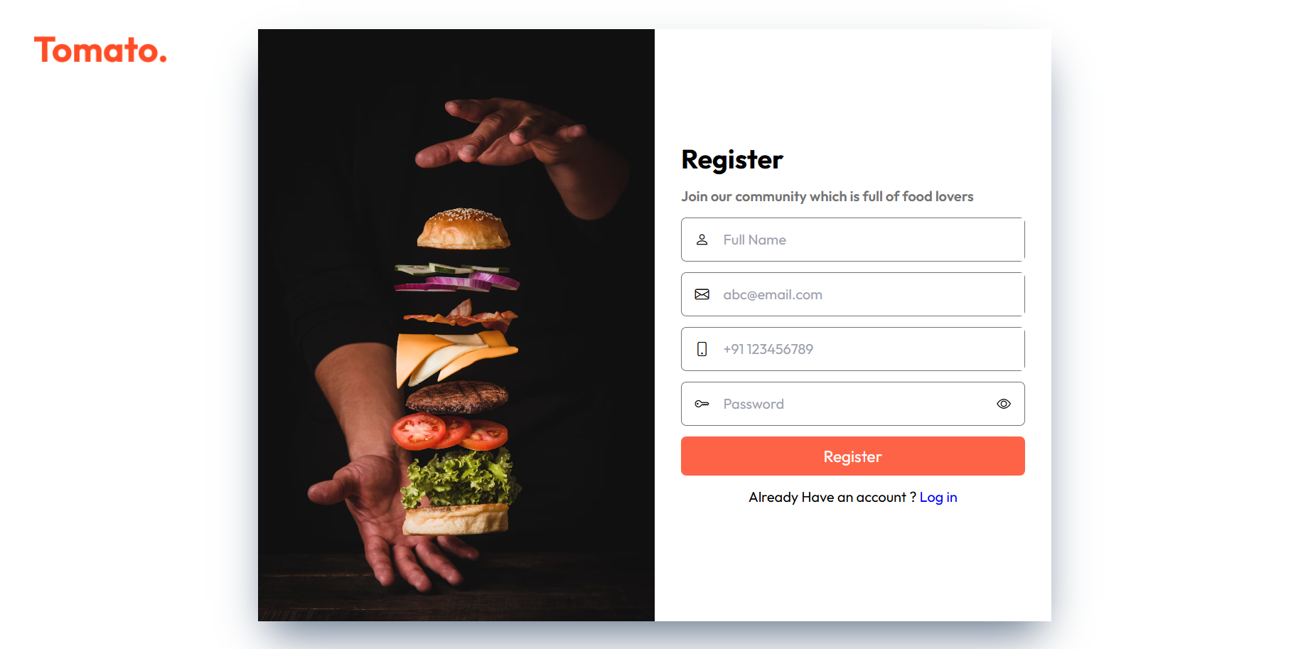

* **Login Page**

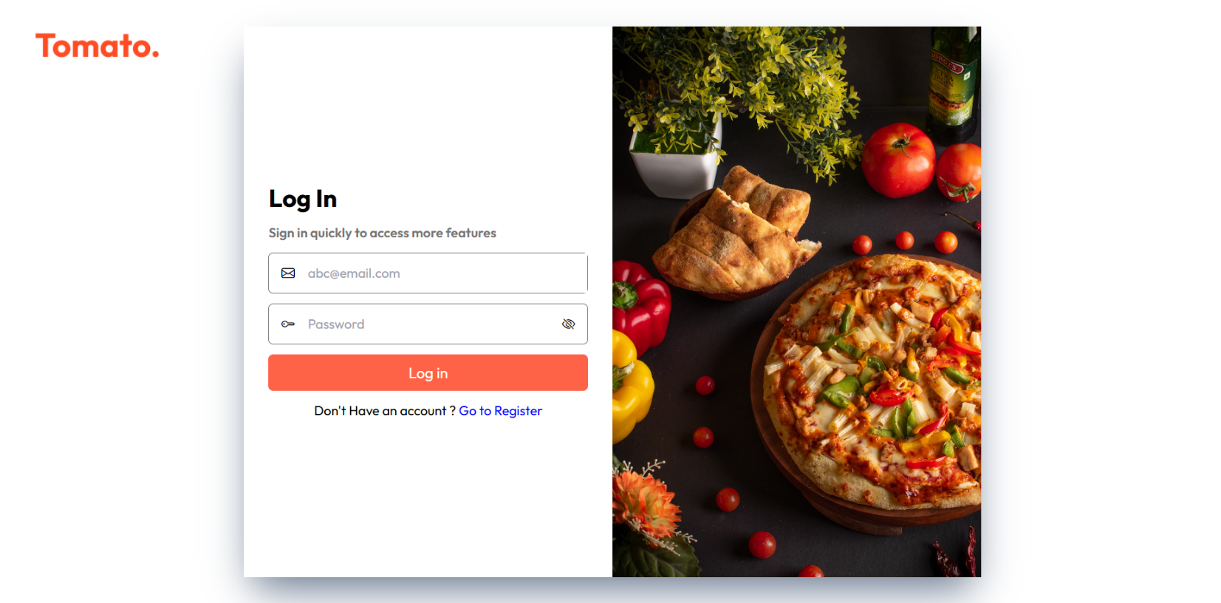

* **Menu Page**

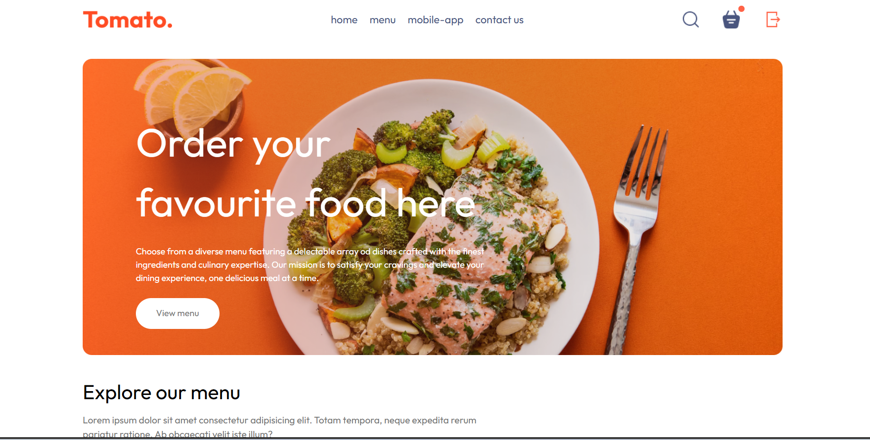

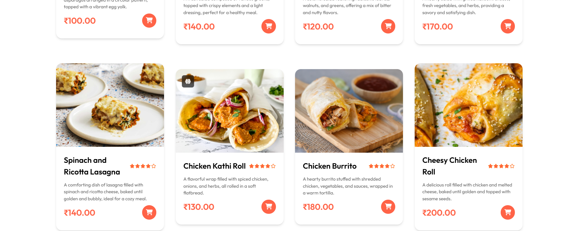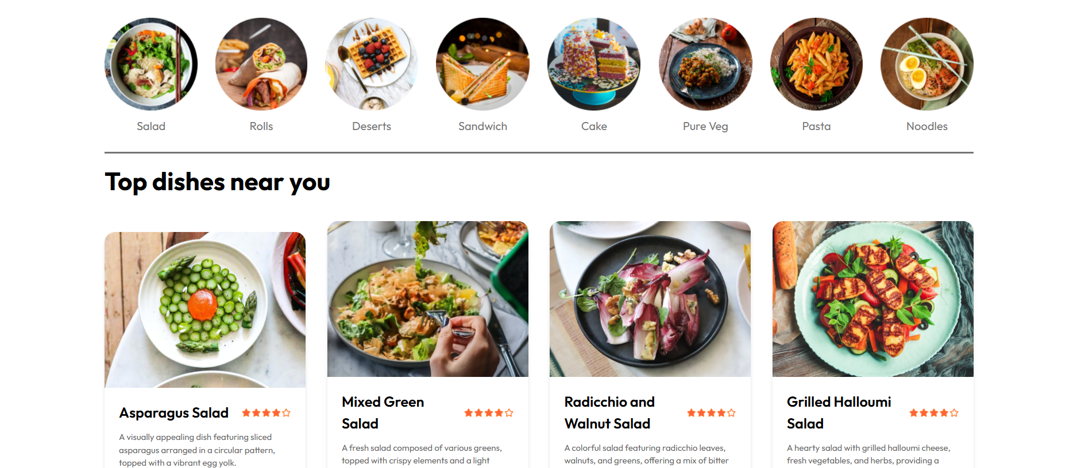**­**

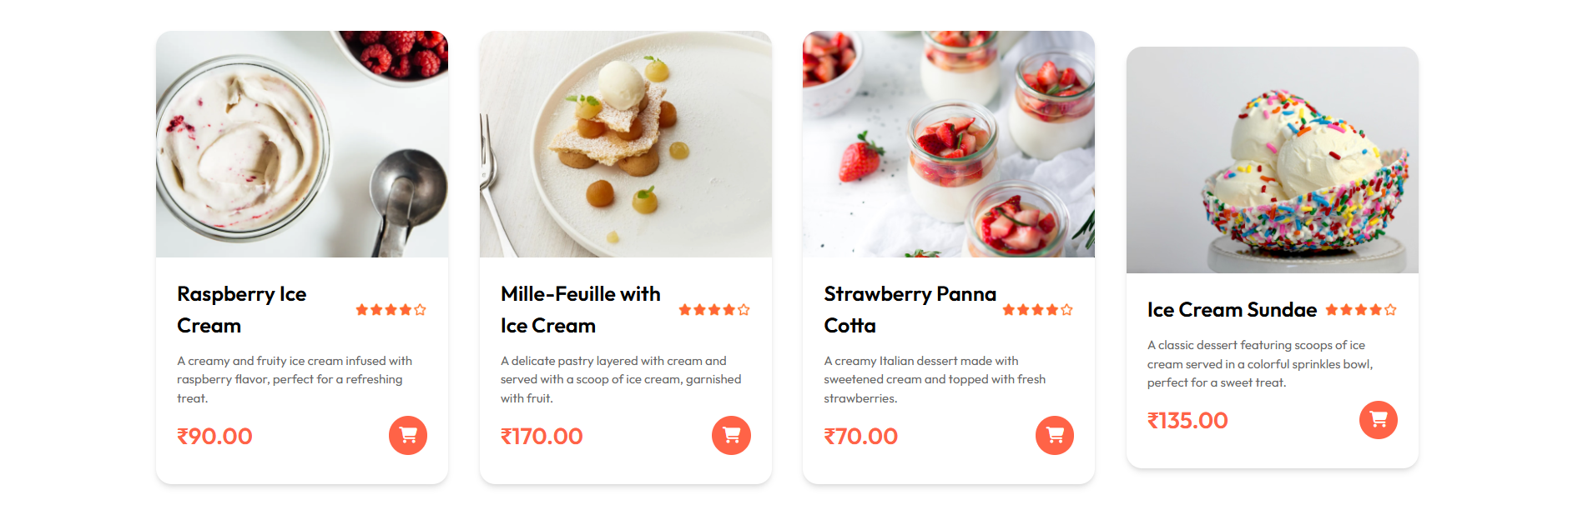

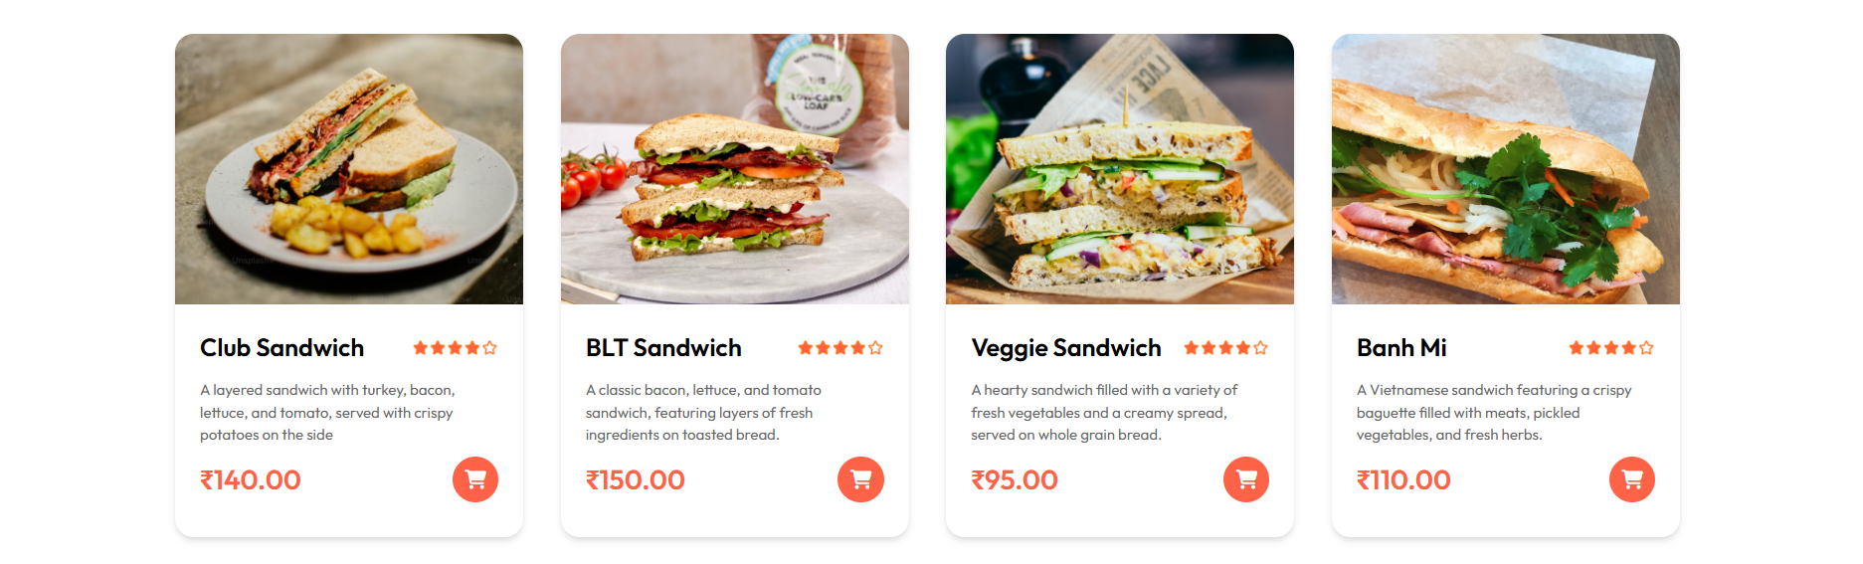

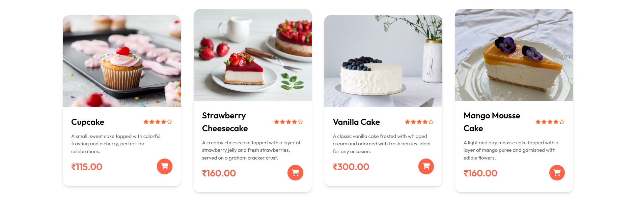

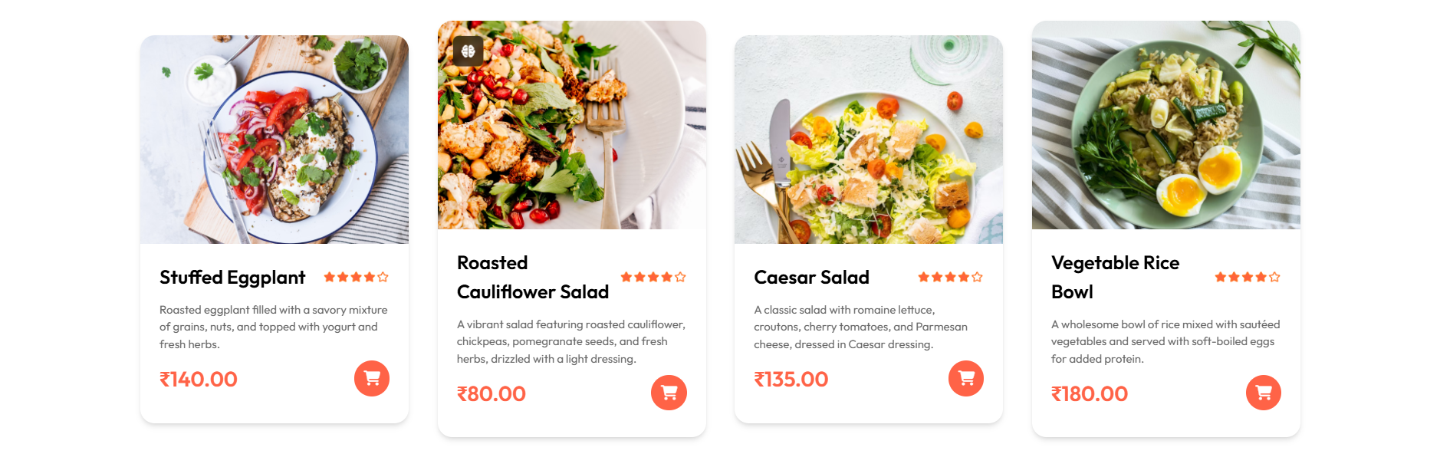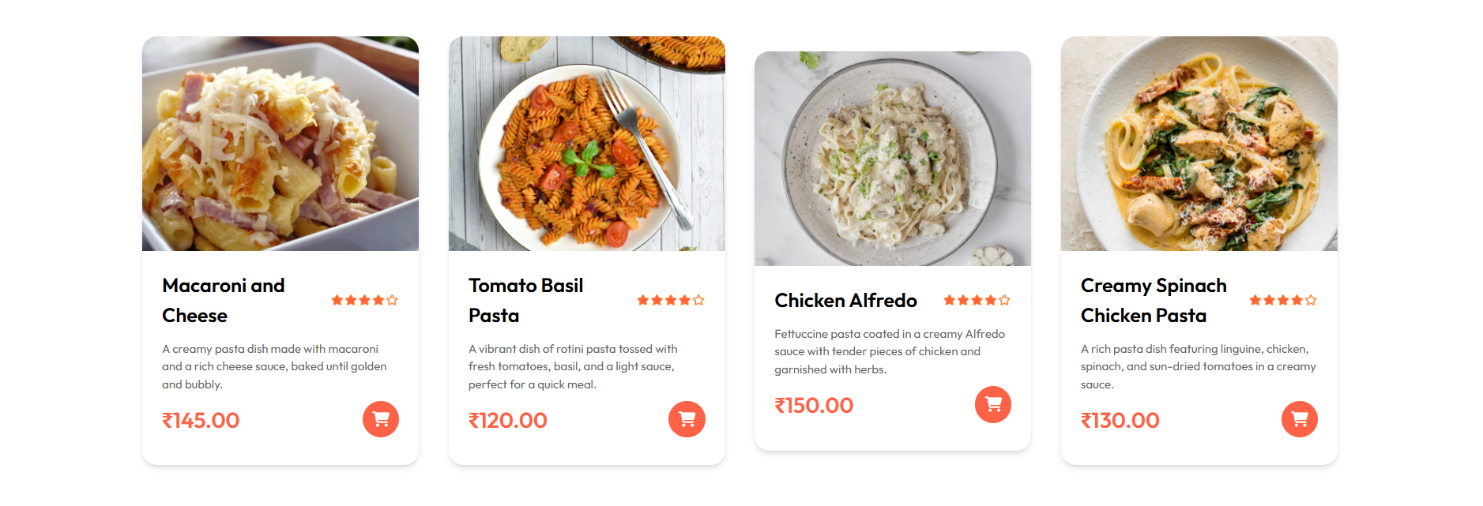



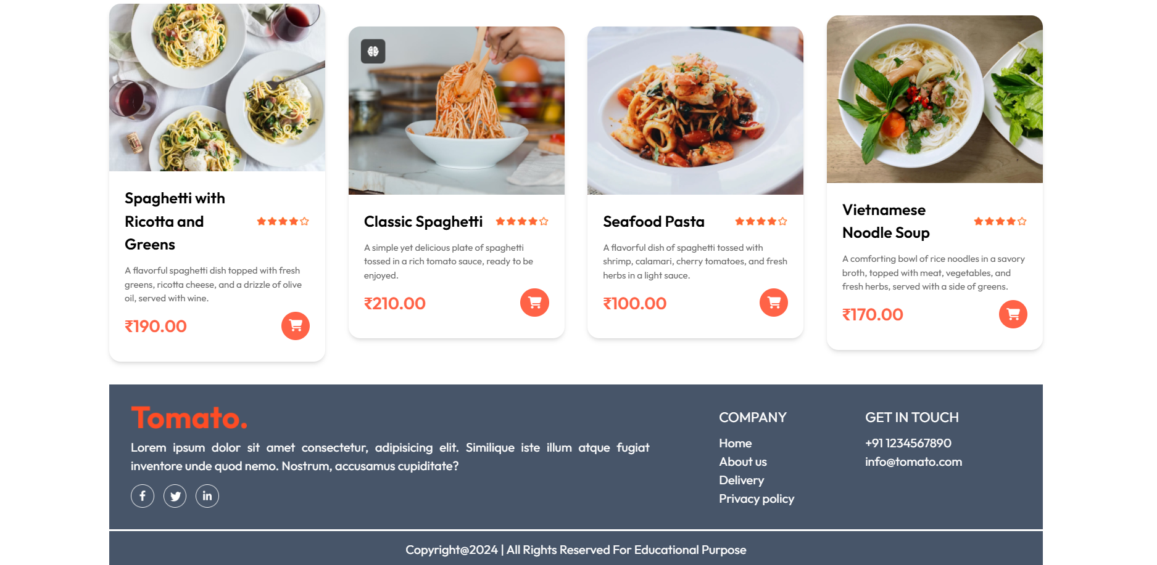

* **Addcart page**

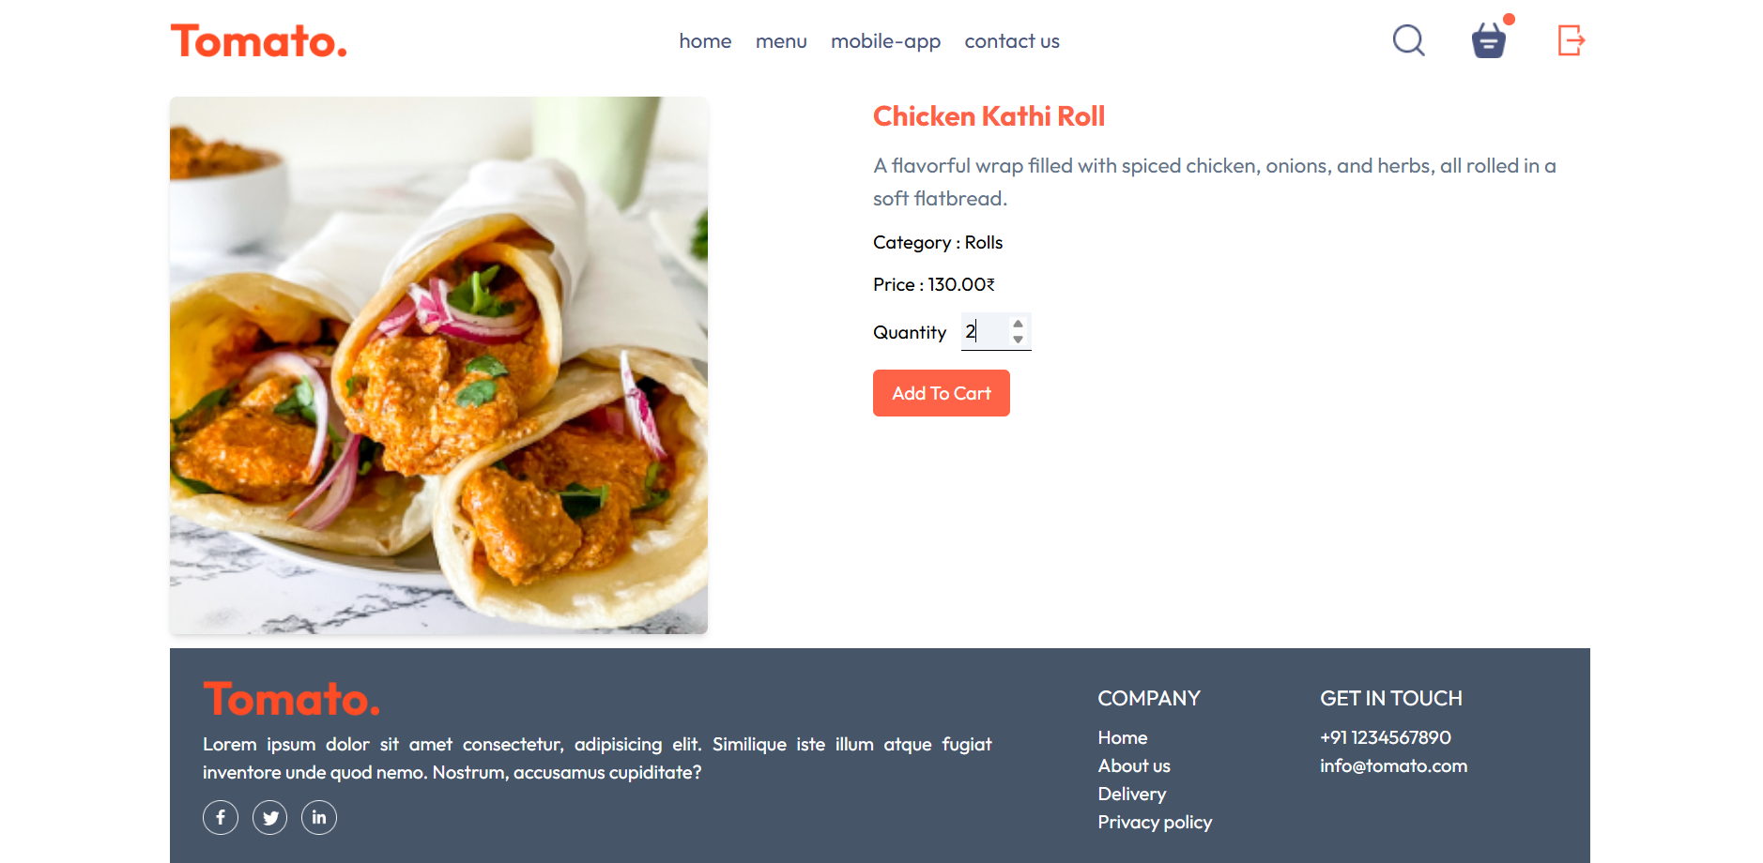

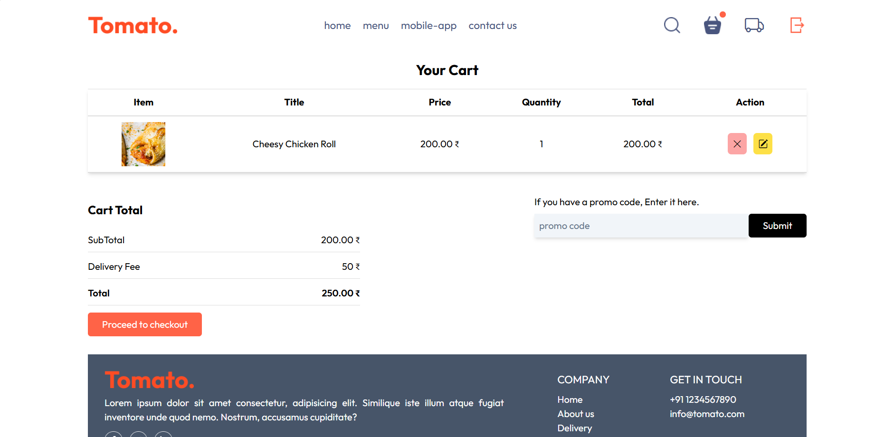

* **Payment page**

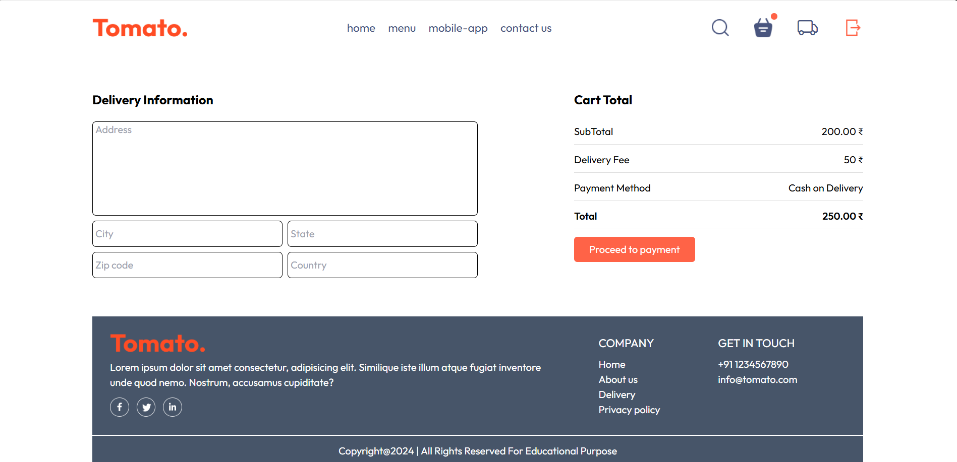

* **OrderTrack Page**

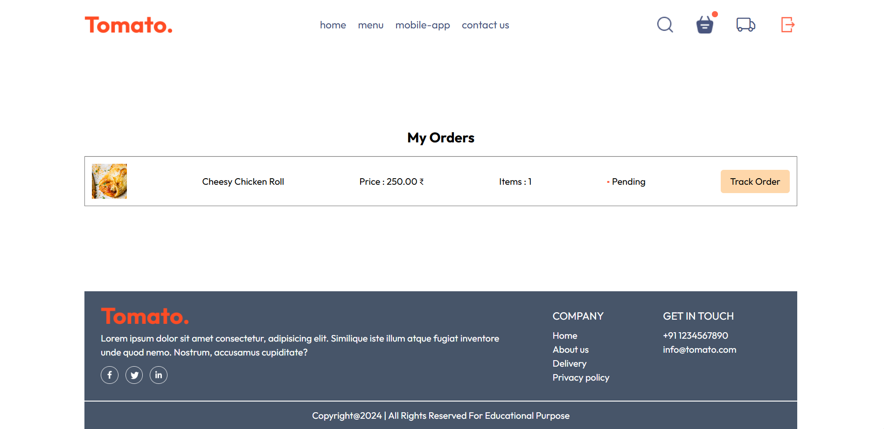

* **AdminPage**

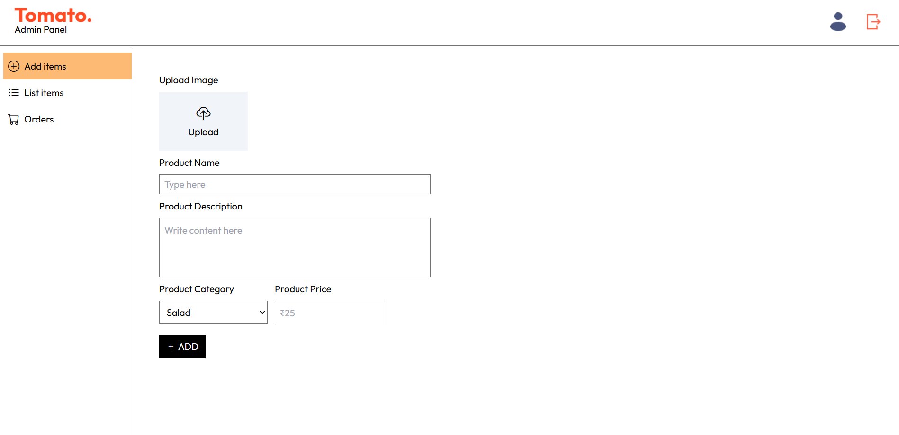

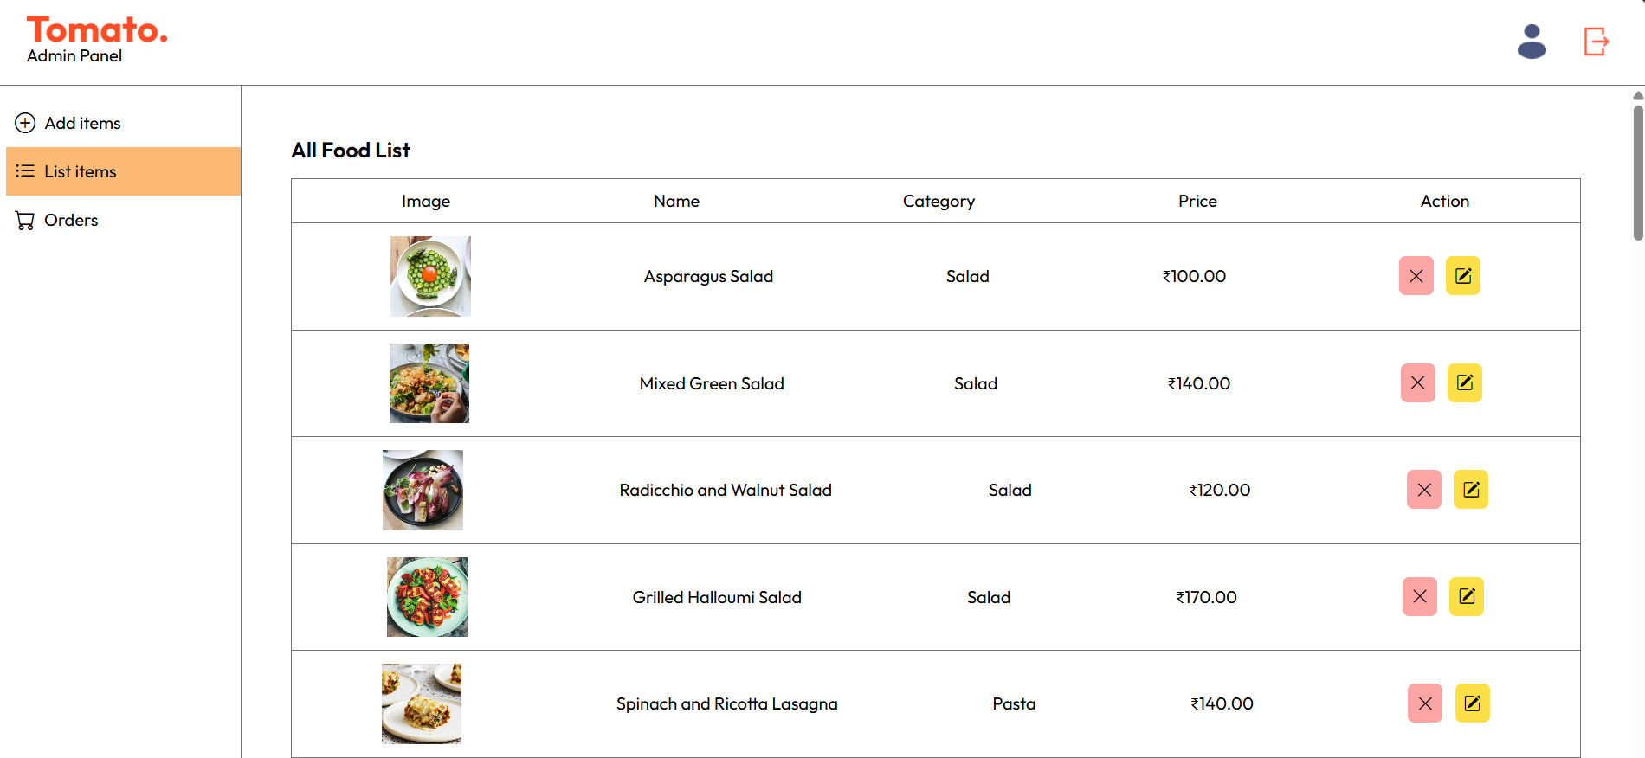

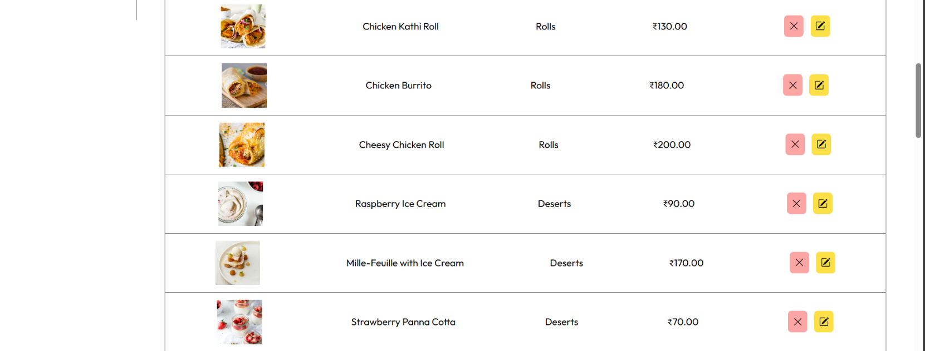

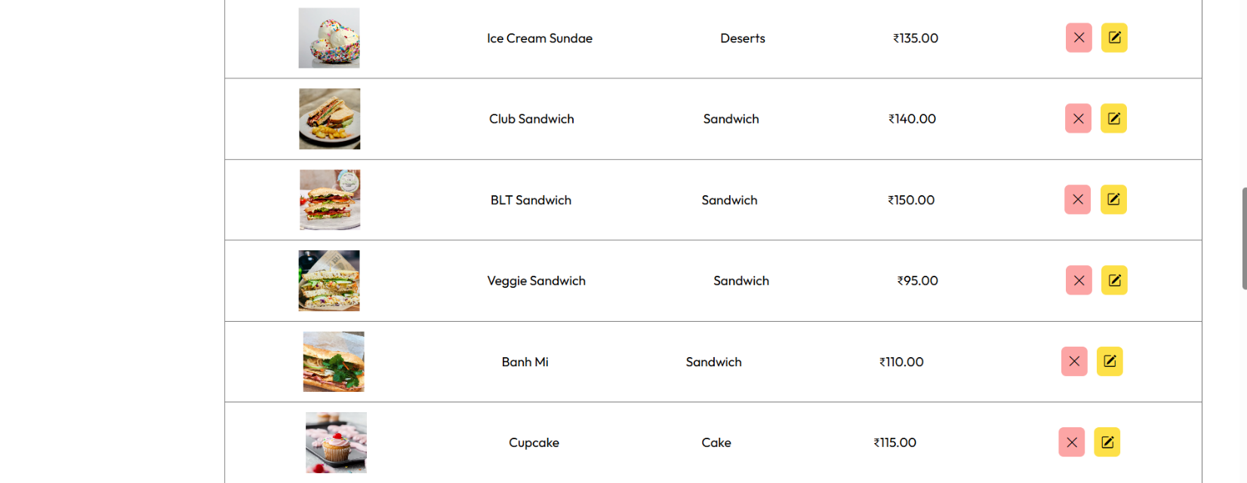

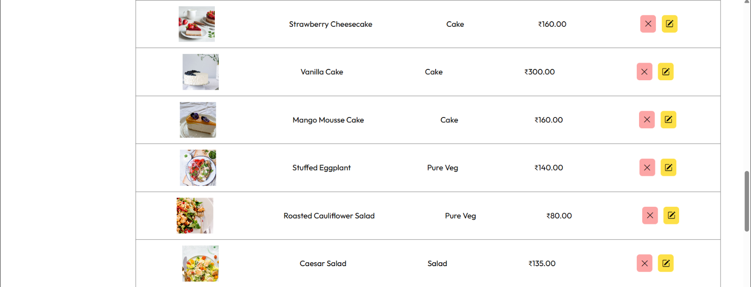

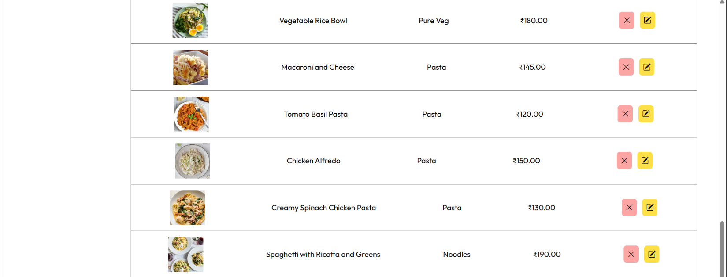

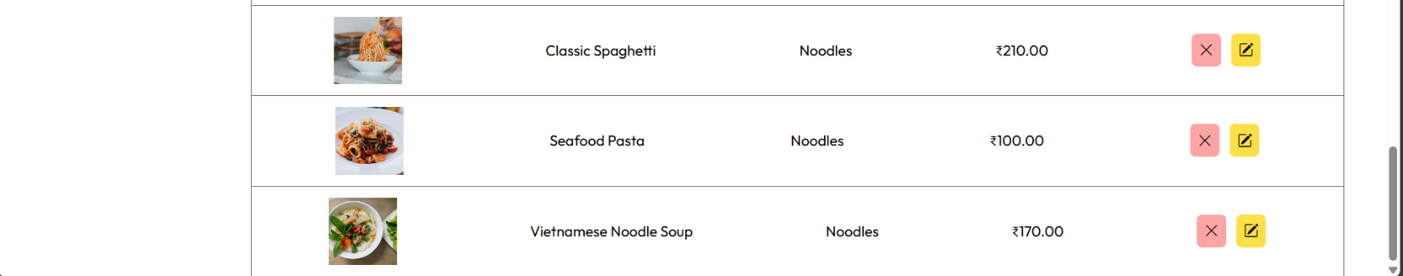

* **CustomerOrder Page**

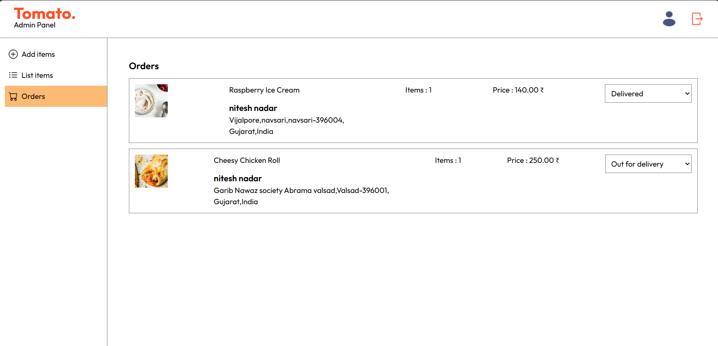

**Conclusion**

* In brief, our project on the website for Food ordering website has successfully created an easy, user-friendly platform that increased the level of dining engagement. It provided intuitive navigation to the users, options of secured payments, and tracking of orders in real time, catering to a few of the main needs of the users while ensuring some of the main operational efficiencies. We tested rigorously with continuous feedback from users to ensure that the experience for customers and food providers was seamless. This would have to be continuously updated and improved, and new feature introductions would be dictated by changing trends and consumer preferences. In the end, this project will satisfy today's demand and position us for growth as well as further innovation in food service.

**References**

* **HTML References**

w3schools : <https://w3schools.com/html/>

HTML Reference : <https://htmlreference.io/>

MDN : <https://developer.mozilla.org/en-US/docs/Learn/HTML>

* **CSS References**

CSS References : <https://cssreference.io/>

W3schools : <https://www.w3schools.com/css/>

TailwindCSS Cheatsheet: https://nerdcave.com/tailwind-cheat-sheet

* **JavaScript References**

W3schools : <https://www.w3schools.com/js/>

MDN : <https://developer.mozilla.org/en-US/docs/Web/JavaScript>

DevDocs : <https://devdocs.io/javascript/>

Geeksforgeeks : <https://www.geeksforgeeks.org/javascript/>

* **MySQL References**

W3schools: <https://www.w3schools.com/MySQL/default.asp>

Javatpoint: <https://www.javatpoint.com/mysql-tutorial>/

Tutorialpoint: <https://www.tutorialspoint.com/mysql/index.htm>

* **Flask References**

Tutorialpoint: <https://www.tutorialspoint.com/flask/index.htm>

Javatpoint: <https://www.javatpoint.com/flask-tutorial>